Foods 9-10(B) 2017 Vint Name: __________________________ Blk: ______

EQUIPMENT SEARCH
Match the following definitions with the name and picture of the piece of equipment. Pictures on back.

EQUIPMENT NAME | PICTURE  # | FUNCTION | LOCATION
 |  | Drains liquid from foods (ex - pasta). Has legs or rim around the bottom to raise it up a bit in the sink.
 |  | Sifts flour or lets liquid drain from food.
 |  | Shreds or grates foods.
 |  | Peels fruits or vegetables. The point can be used for removing blemishes, bruises or potato “eyes.”
 |  | Cleans sides of bowls and removes batter from bowls; used to “fold in” ingredients.
 |  | Levels off measurements on dry measuring cups and measuring spoons; used to ice cakes.
 |  | Removes foods (ex - cookies) from the pan and turns foods over in a frying pan.
 |  | A hand tool used to “cut in” solid fats to flour mixtures, such as biscuits and pie dough.
 |  | Cuts, peels and slices small food items.
 |  | Chops, minces and slices large or small food items.
 |  | Protects the counter surface while cutting or chopping foods.
 |  | Used for hand beating/whipping liquid ingredients.
 |  | Allows hot products to cool evenly; protects counter tops from being burned by hot pots or pans.
 |  | Used to measure small amounts of liquid or dry ingredients.
 |  | Soups and sauces are cooked in this on a stove top.
 |  | Lifts larger pieces of food out of boiling water (ex - corn cobs); turns meat while cooking without piercing it.
 |  | Used to measure liquid ingredients such as milk.
 |  | Used to mix batters or to stir hot liquids on the stove top.
 |  | Holds muffin batter while baking.
 |  | Used to evenly flatten dough when making pies, cookies or biscuits.

1.  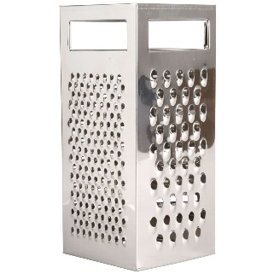 | 2.  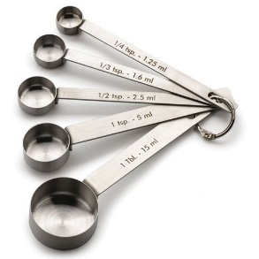 | 3.  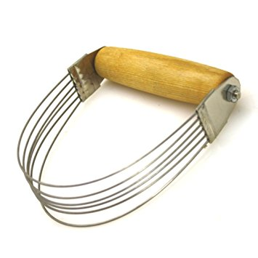 | 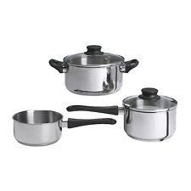  4.
5.  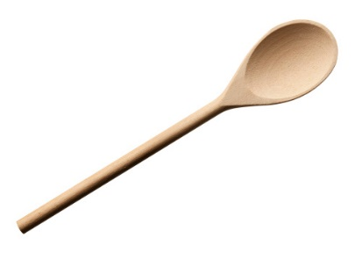 | 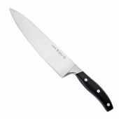  6. | 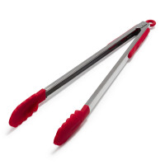  7. | 8.  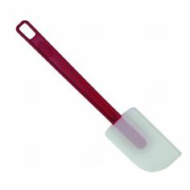
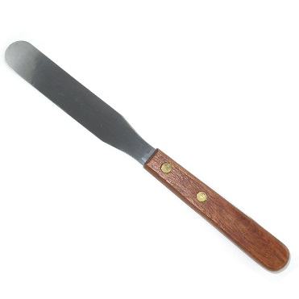  9. | 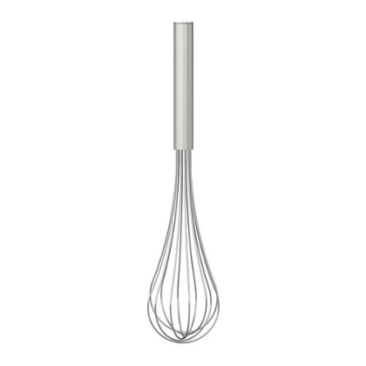  10. | 11.  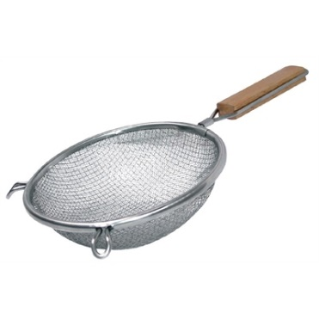 | 12.  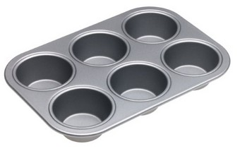
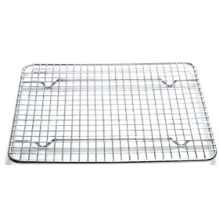  13. | 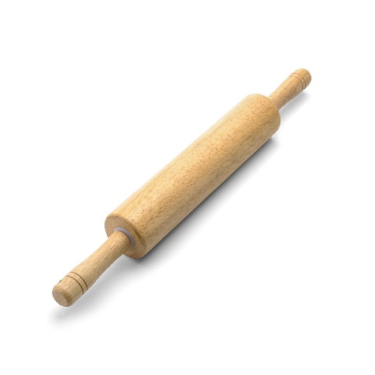  14. | 15.  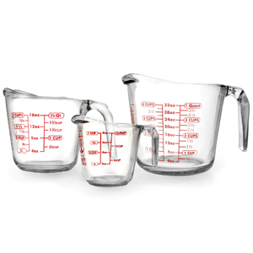 | 16.  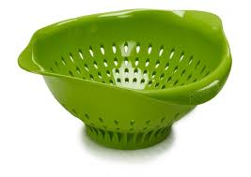
17.  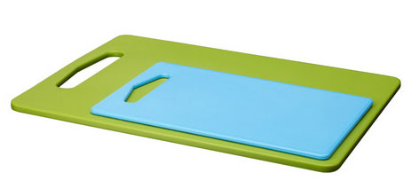 | 18.  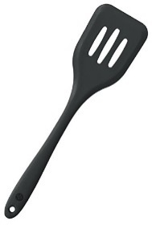 | 19.  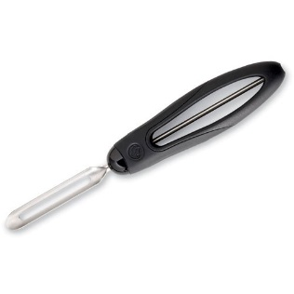 | 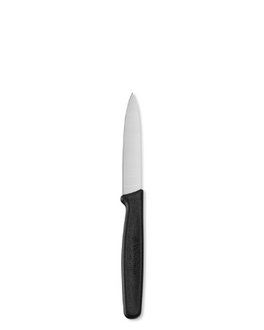  20.

