APFELKUCHEN
(Bavarian Apple Cake)
One recipe per unit of 4-5

Apples, spices and nuts are traditionally used in German and Austrian Christmas baking.
This “cake” is relatively heavy, almost like a cross between cake and shortbread.

250 mL sifted flour
10 mL baking powder
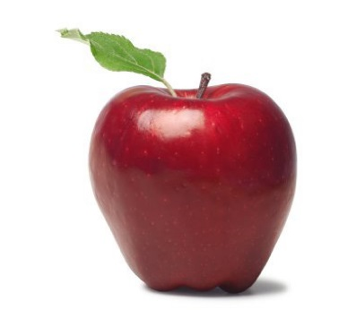
1 mL salt
60 mL sugar
40 mL margarine (room temperature)
½ egg
40 mL milk
1 apple, peeled, cored and thinly sliced
TOPPING:
5 mL cinnamon
20 mL sugar

- Preheat oven to 350ºF. Grease and flour an 8” round cake pan.
- In a large mixing bowl, cream margarine with the back of a wooden spoon until light and fluffy. Beat in the egg until thoroughly combined.
- In a separate medium mixing bowl, combine the sifted flour, baking powder, salt and 60 mL sugar. Add dry ingredients in to the egg/margarine mixture, stirring until the mixture is crumbly. Gradually mix in the milk until the mixture forms a dough that holds together when pressed in your hand.
- Using your hands/fingers, press the dough in to the prepared cake pan. Be sure to smooth the top of the cake so that it is evenly thick.
- Arrange apple slices, slightly overlapping, on top of the dough. Sprinkle with cinnamon/sugar mixture.
- Bake for about 20 minutes or until apples are tender and edges of the cake are golden brown.
- Serve while still warm.
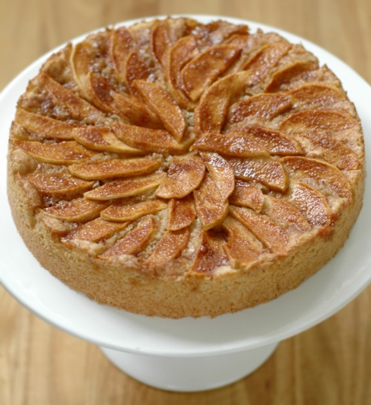

Vint 2015 Foods 9-10 A

Questions for Apfelkuchen Lab

- How do we measure half of an egg? (Please list the steps.)

- Why should the margarine be at room temperature? (2 reasons)

a.

b.

- Why is it important that the apples are thinly sliced?

- It is possible to buy cinnamon sugar in the spice section of a grocery store, but it saves a lot of money if you make it yourself using a ratio of _____ (sugar) : _____ (cinnamon).

- How will you prepare this cake pan for baking?

1.

2.

- If the edges are slightly overcooked, what should you do before serving it to your guests?

