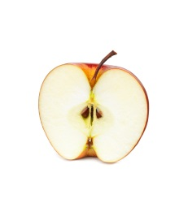
Apple Oat Crisp
2-3 servings

Fruit crisp may be made with various types of fruit or mixtures of fruits (such as apple, peach, pear, plum or cherry) and/or berries (such as raspberries, blackberries, blueberries, cranberries etc.), You can even toss in a handful of raisins, nuts or coconut.
Good varieties of apples for cooking are those that maintain their shape and fairly firm texture when cooked, and those with a good balance of sweet and tart flavours such as Fuji, Gala, Granny Smith, Jonagold, McIntosh or Rome.
Apples: Topping:
2 apples 60 mL brown sugar
60 mL flour
25 mL white sugar 90 mL rolled oats
½-1 mL cinnamon 1 mL cinnamon
60 mL margarine

- Preheat oven to 375ºF (180C).
- Grease one medium or 2 small (individual) casserole dishes with margarine.
- Wash and peel apples. Remove cores with an apple corer tool or cut into quarters lengthwise and remove core with a paring knife.
- Slice apples cross-wise about 2-3 mm thick and place in a medium mixing bowl. Toss apple slices with the white sugar and cinnamon from the “Apples” column of ingredients. Layer apple slices in the bottom of the casserole dish.
- Meanwhile, in a medium bowl, stir together brown sugar, flour, oats and cinnamon.
- Using a pastry blender, cut in the margarine until mixture is well blended but still crumbly.
- Sprinkle the topping evenly over the apples.
- Bake, uncovered, for about 15 minutes or until apples are tender to a fork.

Try at home: Instead of white sugar & cinnamon, toss sliced apples with 15 mL maple syrup and 25 mL walnuts before placing in casserole dish.

