**C:\Users\Vint\AppData\Local\Microsoft\Windows\Temporary Internet Files\Content.IE5\XFAD7HXX\MC900300097[1].wmfAPPLE SQUARES (snack cake)**

**One recipe per 2-3 people**

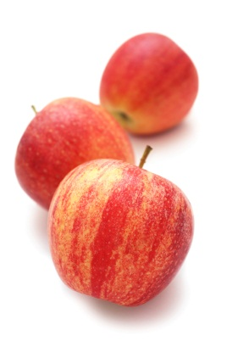**INGREDIENTS:**

50 mL margarine 3 Tbsp

125 mL sugar ½ cup

1 egg 1

2½ mL vanilla ½ tsp

125 mL flour ½ cup

2½ mL baking soda ½ tsp

½ mL cinnamon ⅛ tsp

250 mL apples, finely chopped 1 cup

(about 1 small or ½ med-large size apple)

**METHOD:**

C:\Users\Vint\AppData\Local\Microsoft\Windows\Temporary Internet Files\Content.IE5\OHR1RI9F\MC900413624[1].wmf

1. Place oven rack slightly below centre position. Preheat oven to 350ºF.
2. C:\Users\Vint\AppData\Local\Microsoft\Windows\Temporary Internet Files\Content.IE5\RMGJ11NN\MC900340980[1].wmfGrease a large loaf pan with shortening, making sure the bottom and sides are completely covered.
3. In a large mixing bowl, cream together margarine and sugar until light and fluffy.

C:\Users\Vint\AppData\Local\Microsoft\Windows\Temporary Internet Files\Content.IE5\U1UOG54S\MC900352355[1].wmf

1. Add egg and vanilla and beat until well combined.
2. In a separate medium bowl, stir together flour, baking soda and cinnamon.
3. Add combined dry ingredients to creamed mixture and stir with a wooden spoon until all ingredients are evenly distributed.

C:\Users\Vint\AppData\Local\Microsoft\Windows\Temporary Internet Files\Content.IE5\XFAD7HXX\MC900341012[1].wmf

1. Gently stir in chopped apples until just combined.
2. Using a rubber spatula, scrape all the batter into the greased loaf pan and level off the top.
3. Bake for 15-20 minutes or until a toothpick inserted in the centre comes out clean and the cake begins to pull away from the sides of the pan.
4. Remove pan from oven to a wire rack to cool for a few minutes.
5. Cut cake into 8 squares and carefully remove them from the pan with a thin metal flipper.

Vint – October 2012