NAME _______________________________________________ BLOCK ______ UNIT ______
Kitchen Safety and Sanitation in the Foods Lab
***IF YOU GET AN INJURY DURING CLASS TIME, REPORT IT AT ONCE TO THE TEACHER, EVEN IF YOU THINK YOU MIGHT BE ALRIGHT***
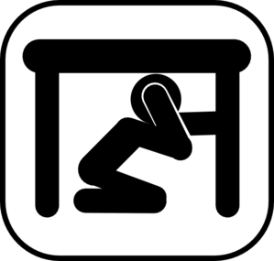
Earthquake
If an earthquake should occur, the following procedures are to be taken:
- Take cover __________________ a desk or table.
- Face __________________ from windows.
- Assume "crash position".
- Exit the room when safe, stay in a ___________________ and keep away from the school.
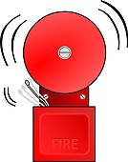
Fire Drill
When the fire alarm sounds:
- Turn _______________ stove elements, the oven, and all equipment.
- Move quickly and quietly from the room to _______________ .
- Stay in the group away from the ______________________ .
Fire in the Classroom
- Fire inside the oven:
  - Turn off the _______________, shut the oven door and the fire will _________________________ .
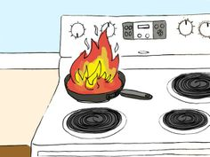
- Fire in a frying pan on top of the stove:
  - Cover immediately with ________________, and turn off the element.
  - Sprinkle with ________________________________ to extinguish flames. This is located in ________________________________________ . (Answer from teacher.)
- Electrical fire:
  - Use fire extinguisher located _____________________________________ . (Answer from teacher.)
  - Do not pour _________________________ on it or the fire will spread.
- Clothing fire:
  - If clothing catches fire, _______________ , _______________ and _____________.
  - Lab partner or teacher should smother flames with a heavy coat.
In Case of Burns
- If you burn yourself, rinse the burnt area under _______________, _______________ _______________ for _______________ to take away the sting.
- Ask partner to inform teacher that you have burnt yourself.
10 minutes | drop | lid | stop | water
away | exit | off | running | under
baking soda | extinguish | oven | school | water
cool | group | roll
In Case of Cuts
- If you cut yourself, put the cut under _____________ , _____________ ______________ .
- If the bleeding persists, _______________ the cut, elevate the cut area and apply _________________ .
- Inform teacher for further __________________________ treatment.
In Case of Choking
Call for help! Perform the __________________________ if you are trained in this first aid skill.
GENERAL NOTES ON KITCHEN SAFETY AND SANITATION
Hands, Hair and Clothing
- _______________ hands and nails well before starting to cook.
- Tie hair back and do not touch hair while __________________________ food.
- _____________________ coats or layered clothing during a lab.
- Roll up long ___________________, remove rings and other jewelry while _____________ with food. Better yet, keep it at home so there is no chance of it getting lost or stolen.
- Wear a _____________ apron and keep apron properly _______________ .
- Do not lick your fingers while handling _____________.
- Do not sneeze or cough _____________ food; wash hands immediately afterwards.
Breakages
- Inform ____________ ; use broom (not ____________ ) to sweep up broken pieces.
- Pick up very fine pieces with a damp ________________________ .
Spills
- _______________ the teacher, so s/he can warn the class to be aware of the spill site.
- Wipe up spill immediately; mop up spill. If the spill is _______________ , use a small amount of dish soap. Rinse and clean the mop.
Knives
- Carefully use knives, grater and other sharp instruments.
- Always cut ____________ from yourself.
- Carry all knives with the blade pointed __________ .
- Never leave knives, graters and other sharp instruments in a sink with _____________ ___________. Wash separately, dry immediately and store carefully - only the dishwasher should place dishes in the soapy water.
away | down | Heimlich maneuver | pressure | tied
bubbly | first-aid | Inform | Remove | wash
cool | food | near | running | water
cover | greasy | paper towel | sleeves | water
clean | hands | preparing | teacher | working

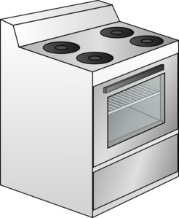
Working at the Stove
- Never place _________________ pots or pans on heated elements.
- Turn all pot handles __________________the middle/center of the stove.
- Do not leave fat or grease cooking ________________________ .
- Do not leave flammable objects (oven mitts, recipes, dish cloths, etc.) ____________ or __________ the stove.
- Use wooden spoons when stirring _____________________ on the stove, not metal spoons - they conduct heat.
Rubber spatulas may be used ONLY if they are heat resistant; otherwise, they may melt.
- When taking a lid off a saucepan, lift it __________________ your body (tip the farthest side up first) so rising steam does not burn your face or arms.
- Always try to match the ____________ of pot or pan to the same size of stove top element.
- ________________ oven racks before turning on the oven.
- Open oven door completely & pull out oven racks slightly when putting in or removing baking pans. Always wear ____________ ____________ .
- Use a taster spoon when sampling, never the ____________ ____________ .
- Keep hot foods hot (above 60° C) and cold foods cold (below 4°C); between these temperatures is the ____________ ____________ and foods will become unsafe to eat after a time.
- Check to make sure the elements and the oven are turned off when not in ____________ .

Working at the Preparation Counter and Sink
- Cut on cutting boards not on ________________________ .
- Do not "cross contaminate" by using the same ________________________________ for uncooked meat and then for other food items.
- Use hot water to ____________ and rinse dishes.
- Soak greasy dishes in ____________ water, egg and milk dishes in ____________water.
- Stack dirty dishes ______________________ to prevent them from falling.
- Never place a hot pan in ___________ ____________ - let the pan cool first, as extreme temperature changes can cause warping.
- Use a dish drainer and rubber mat for ________________ ________________ .
- Do not use a drying towel for wiping _____________- use a mop or paper towel.

adjust | dishes | liquids | spoon | water
carefully | drying | mitts | stirring | zone
cold | empty | on | towards | use
countertops | floors | oven | towards
cutting board | hot | over | unattended
danger | dish | size | wash

Electrical Appliances
- Always check to ensure that the appliance is ____________ before you plug it in.
- Make sure your hands are ____________ before handling electrical appliances.
- Pull plugs out of the electrical sockets; do not pull ____________.
- Keep appliances always away from ____________ and never immerse electrical motors in water
- Make sure cords are not sitting on stove ___________________.
Classroom
- Keep drawers and cupboard doors ____________.
- Do not lean back on _______________.
- During labs, keep chairs __________________ in and push chairs in when you leave.
- Leave books and other supplies under your ______________ or chairs during labs.
- Put all garbage in the garbage can and recyclables in the __________________ ____________ located _________________________________________________ . (Answer from teacher.)
- Food scraps and food-soiled paper towels are placed in the ____________________________ bin, located _______________________________________________ . (Answer from teacher.)

bin | cords | off | table
chairs | dry | pushed | water
closed | elements | recycling | compost
***PLEASE DO NOT LEAVE THE ROOM UNTIL YOUR UNIT HAS BEEN CHECKED FOR PROPER CLEANUP BY THE TEACHER ***

