KITCHEN SAFETY POSTER PROJECT

Cooking is considered a relatively safe activity/occupation, but hazards do exist in food preparation and in related tasks. Kitchens have many safety hazards. There are hot stoves, ovens, pans, and food. There are electric appliances that can be dangerous. There are sharp knives and tools.

The pace in most kitchens is fast and busy, with time constraints and a necessity for precise timing to have multiple products ready at the same time. This pace, combined with the hazards presented by the use of kitchen equipment, can increase the risk for personal injuries. Therefore, it is important that you work carefully but quickly, while giving your full attention to safe practice. Accidents can occur in many ways, but most can be traced back to ignorance of safety rules or to carelessness and lack of focus. The vast majority of kitchen injuries are preventable. The most common accidents in the kitchen are: cuts, burns, falls and sprains.

ASSIGNMENT: Each student will create a small “Kitchen Safety” poster on the provided heavy paper. The poster must focus on ONE aspect of kitchen safety. Each student in your group must choose a different topic. There should be few (if any) words so that the message is understandable to anyone, regardless of age or language.

NAME: ______________________________________ BLK: _____ UNIT: _____

Evaluation: Kitchen Safety Poster
CRITERIA:

- Name and block are printed neatly on the BACK of the poster.
- Handed in on time. DUE DATE: _________________
- Safety Tip: is obvious at a glance, with little or no printing/text.
- Illustration: is original & creative, presented neatly, good effort is apparent.
- Overall Presentation: eye-catching and clear/clean presentation; paper is not torn, crumpled or folded; bold lines; bold, appropriate colours.
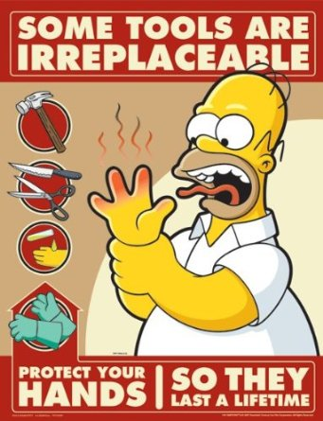
TOTAL SCORE: _______ /20
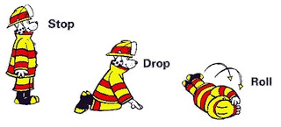

NAME: ______________________________________ BLK: _____ UNIT: _____

Evaluation: Kitchen Safety Poster
CRITERIA:

- Name and block are printed neatly on the BACK of the poster.
- Handed in on time. DUE DATE: _________________
- Safety Tip: is obvious at a glance, with little or no printing/text.
- Illustration: is original & creative, presented neatly, good effort is apparent.
- Overall Presentation: eye-catching and clear/clean presentation; paper is not torn, crumpled or folded; bold lines; bold, appropriate colours.
TOTAL SCORE: _______ /20

KITCHEN SAFETY POSTER PROJECT

Cooking is considered a relatively safe activity/occupation, but hazards do exist in food preparation and in related tasks. Kitchens have many safety hazards. There are hot stoves, ovens, pans, and food. There are electric appliances that can be dangerous. There are sharp knives and tools.

The pace in most kitchens is fast and busy, with time constraints and a necessity for precise timing to have multiple products ready at the same time. This pace, combined with the hazards presented by the use of kitchen equipment, can increase the risk for personal injuries. Therefore, it is important that you work carefully but quickly, while giving your full attention to safe practice. Accidents can occur in many ways, but most can be traced back to ignorance of safety rules or to carelessness and lack of focus. The vast majority of kitchen injuries are preventable. The most common accidents in the kitchen are: cuts, burns, falls and sprains.

ASSIGNMENT: Each student will create a small “Kitchen Safety” poster on the provided heavy paper. The poster must focus on ONE aspect of kitchen safety. Each student in your group must choose a different topic. There should be few (if any) words so that the message is understandable to anyone, regardless of age or language.

