Beef and Potato Curry
Makes 4-5 servings (one recipe per unit)
Serve this one-pot family pleaser with warm naan or pita bread and raita (fresh yogurt relish) or a cucumber and tomato salad.

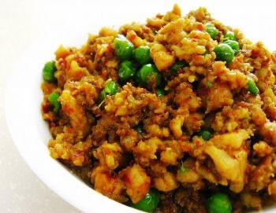
250 g lean ground beef
½ medium onion, chopped
1 large clove garlic, minced
15 ml tomato paste
7½ mL mild curry paste or powder
7½ mL ginger root, peeled and minced
½ mL salt
1 med. russet potato, peeled and diced (small dice)
250 mL beef stock (250 mL hot water + 15 mL stock powder)
175 mL frozen peas
25 mL chopped fresh cilantro/coriander or parsley (optional)

- Prepare vegetables as specified above. Smaller pieces of potato will speed the cooking.

- Meanwhile, in a large, heavy pot (use the large “Dutch oven”) over medium heat, cook beef, breaking it up with a wooden spoon, for 5-7 minutes or until no longer pink. Place in a small mixing bowl lined with a paper towel to drain fat. Return drained beef to pan.

- Add chopped onion, minced garlic, tomato paste, curry paste or powder, minced ginger and salt to beef in pan. Cook, stirring occasionally, for about 5 minutes or until onion is softened.

- Add diced potatoes and stock to beef/vegetable mixture in pan. Bring to a boil. Reduce heat, cover and simmer for 10-15 minutes (heat #2-3, so that mixture is bubbling but not boiling hard).

- Stir in frozen peas. Continue to cook, covered, for 3-5 minutes more until potatoes and peas are tender. Remove from heat and stir in chopped cilantro or parsley (if using).
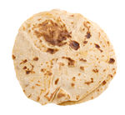
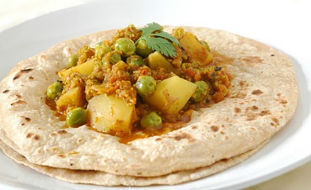

Authentic Cuisine
A typical Indian meal consists of one or two vegetarian, meat, chicken or fish dish(es), a dhal (lentil) dish, rice and/or bread. These are accompanied by a fresh yogurt relish (raita) and an assortment of pickles and chutneys. Indian flatbreads include naan (made with yeast) and chapatti (whole wheat bread similar to flour tortillas). Middle Eastern pita bread is a good alternative.

Tip: For a fast lunch, roll up leftover curries in pita breads or flour tortillas.
Vint 2015

