NAME: ______________________ BLOCK: _____
CEREAL NUTRIENT COMPARISON OF READY-TO-EAT CEREALS

CEREAL | SERVING SIZE | CALORIES | PROTEIN HIGHER IS BETTER | TOTAL CARBOHYDRATES  (CHO = CARBOHYDRATE)  HIGHER IS BETTER | SUGAR  (CHO = CARBOHYDRATE)  LOWER IS BETTER | FIBRE  HIGHER IS BETTER  20-30g per day | FAT  LOWER IS BETTER
FRUIT LOOPS
FROSTED FLAKES
CORN FLAKES
SPECIAL K
FROSTED MINI WHEATS
LUCKY CHARMS
CHEERIOS
SHREDDIES
*Assume serving sizes are equal
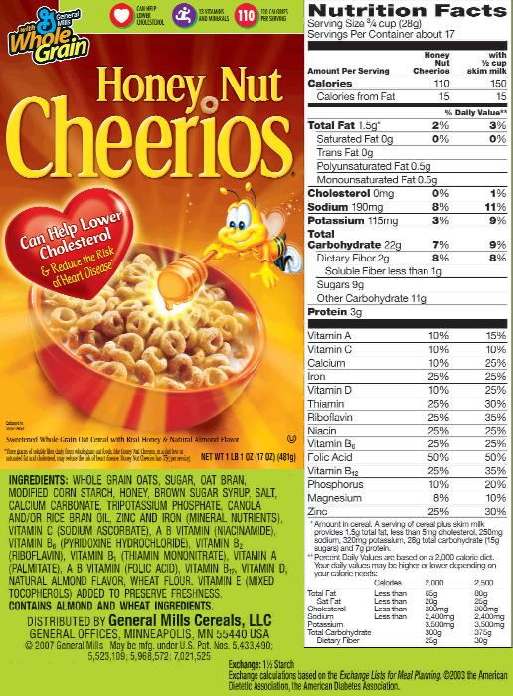
How to Read a Cereal Box
1
2

- All the numbers below are for ONE SERVING. One serving of this cereal is ¾ cup (28g). If you normally eat more or less, be sure to adjust the numbers accordingly.
3
- The first column is for the dry cereal alone. The second column is for the cereal with ½ cup (125 mL) of SKIM milk. Caloric and fat content will be higher if you use 1%, 2% or homogenized milk.
4
- Most cereals contain little or no fat. The exceptions are most granolas and cereals with added nuts.
10
5
- Cholesterol is found only in animal products, so cereals rarely contain cholesterol. Non-fat milk contains little cholesterol while higher-fat types have more.
6
- Some cereals have a surprising amount of sodium, yet they don’t taste “salty.” This cereal has 8% of the Daily Value in a single serving.
8
7
- Many diets lack dietary fibre. Fibre is not a “nutrient” but it might help prevent cancers of the bowel. Two grams is 8% of the Daily Value, which is defined as “a source of” fibre but not a “high source” of fibre (defined as 4g or more of fibre per serving).
9
- How can you know how much of a cereal is sugar? Look at the top of the nutrition panel to find the size of a single serving – here 28g. Next, look at the entry to the right of “Sugars” near the middle of the label – here 9g. So 9g of the 28g serving, or 32% by weight, is sugar.
- Most of these nutrients come from fortification – a vitamin supplement “sprayed” onto the cereal.
- The ingredient list shows a breakdown of the contents by weight of the individual ingredients. This cereal is mainly whole grain oats but has more sugar than oat bran.
- “Health claims” may be made on the packaging.
- Possible allergens may be listed with the ingredients.

11

Nov 2015

