Chocolate Fudge Brownies

60 mL margarine
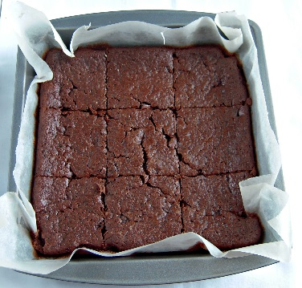
50 mL cocoa
1 egg, beaten
125 mL sugar
2 mL vanilla
100 mL all-purpose flour
1 mL salt
3 mL baking powder
50 mL chopped nuts, finely chopped (optional)

- Preheat oven to 350ºF (175C).
- Generously grease a large loaf pan or line with parchment paper.
- Combine margarine and cocoa in a heat-resistant liquid measure. Cover with a paper towel to avoid splatters and microwave on high power for 30 seconds. Stir with a rubber spatula. Microwave a few seconds longer if margarine is not completely melted. Let mixture cool slightly.
- Using the same rubber spatula, transfer all of the cocoa mixture to a medium mixing bowl. Add sugar, vanilla and well-beaten egg to the cocoa mixture. Beat until light and fluffy, with either a wooden spoon or an electric mixer.
- In a separate small bowl, sift together the remaining dry ingredients (flour, baking powder & salt).
- Gradually stir the dry ingredients in to the cocoa mixture. Stir in nuts, if using.
- Spread the batter evenly in the prepared loaf pan, pushing batter in to all the corners.
- Bake for about 20-25 minutes or until a toothpick inserted into the centre comes out dry and the brownies have shrunk away from the sides of the pan. The brownies should spring back if touched gently in the centre.
- Let the brownies cool for a minimum of 8-10 minutes before attempting to remove from the pan to prevent the cake from breaking.
