Coconut Chocolate Chip Cookies
Yield: 7-8 medium/large cookies

60 mL butter or margarine, softened
90 mL sugar
½ egg
1 mL coconut extract
140 mL all-purpose flour
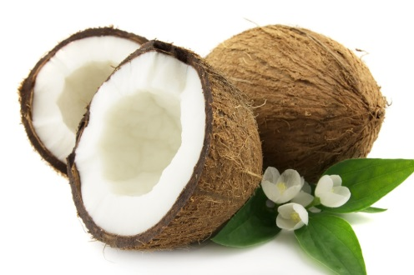
1 mL baking soda
80 mL semi-sweet chocolate chips
60 mL flaked or shredded coconut

*** Preheat oven to 375ºF (190C) ***

- Cream margarine and sugar in a medium mixing bowl.
- Beat in egg and coconut extract; mix well.
- Combine flour and baking soda in a small bowl.
- Using a wooden spoon, stir dry ingredients in to the creamed mixture.
- Stir in the coconut and chocolate chips.
- Drop by rounded tablespoonsful about 5 cm (2”) apart onto an ungreased baking sheet/pan.
- Bake for 8-12 minutes or until cookies are fragrant and they are just beginning to turn golden brown around the edges.
- Allow to cool for 3-5 minutes on the pan and then place on a wire rack to cool completely.

