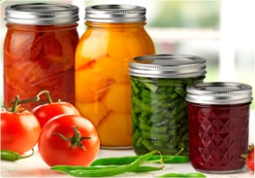
FOOD PRESERVATION

DEFINITION:

Food preservation = caring for or treating food in such a way that it will extend the length of time that food will remain edible and in good, safe condition.
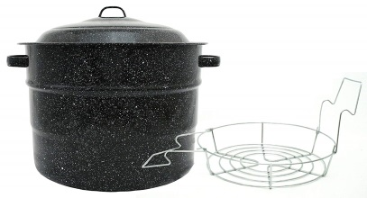
Preserving food stops the activity of enzymes and the growth of micro-organisms that make food deteriorate, spoil or go bad.

WHY PRESERVE?

- Preservation allows food to be transported all over the world.
- Preserving food allows us to enjoy foods not “in season” at any time of year.
- Preserving food allows us to take full advantage of abundant harvests of food we might grow ourselves. Since it often ripens all at once, we can’t always use it all at once.
- Home preserves may be less expensive than buying at the grocery store.
- Convenience - you can have products on hand instead of having to go to the store.
- When foods are preserved and partially prepared/cooked, it saves meal preparation time.
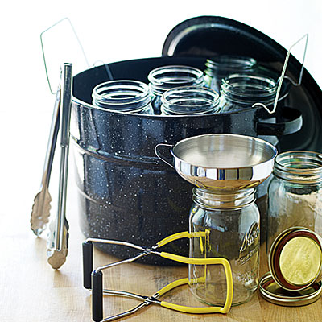
- Preserving your own food means you can control the amount of chemicals, sugar and salt in your food.

METHODS OF PRESERVING:

- High temperature = Canning
- Low temperature = Freezing
- Removing moisture = Drying
- Removing air = Freeze-drying
- Adding preservatives (ex–vinegar; salt) = Pickling

WHAT TO CONSIDER WHEN CHOOSING FOODS TO PRESERVE:
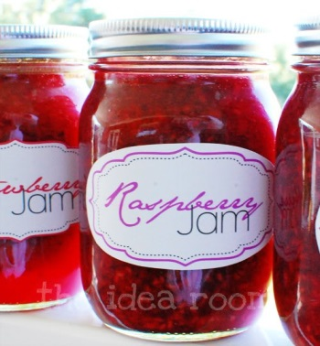
- Freshness
- Quality
- Variety of plant – some varieties preserve better than others.

DRYING/DEHYDRATION

DRYING IS AN ANCIENT METHOD OF FOOD PRESERVATION:

- Indigenous peoples
- Early settlers and pioneers
- Sailors

WHAT HAPPENS WHEN YOU DRY/DEHYDRATE FOOD?
- Removes moisture/water
- Micro-organisms need water, so they can’t grow and spoil food in its absence
- Drying concentrates the flavour, colour and natural sugars in the food

DRYING BASICS:
Requires: 1) increased temperature, and 2) dry, moving air

Temperature: Too cool means drying time is slow food may spoil
Too hot means food may cook quickly on the outside, but stay moist on the inside food may spoil

Air: Moving air absorbs and carries away water need dry, moving air.
Calm, slow air means slow drying time food spoils

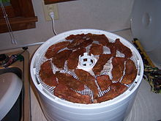
DRYING METHODS:
- In the sun
- In and electric dehydrator
- In the oven
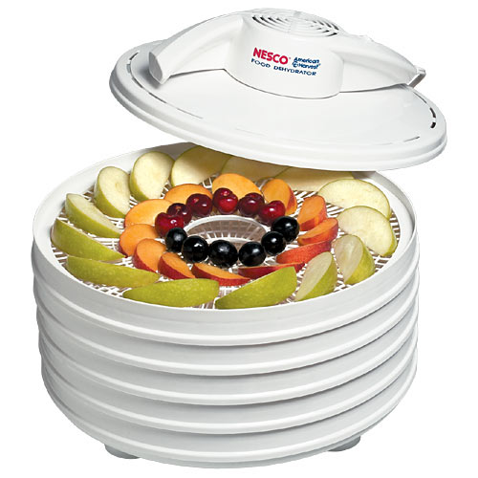
WHAT CAN YOU DRY?
- A variety of fresh fruits, vegetables, herbs and meat.
- You can make trail mix, fruit leather, camping food, jerky.

CHOOSING FRUITS & VEGETABLES:
- Choose the freshest and best quality available.

STORING DRIED FOODS:
- Use air-tight containers or plastic bags.
- Store in cool, dry, dark areas.

Notes – Dehydrating

☼☼☼☼☼☼☼☼☼☼☼☼☼☼☼☼☼☼☼☼☼☼☼☼☼☼☼☼☼☼☼☼☼☼☼☼☼☼☼☼

- Removes water so micro-organisms can’t grow and spoil foods.
- Concentrates the flavour, colour and natural sugars in foods.
- Always dry foods at their peak of freshness, flavour, ripeness and colour to maintain maximum flavour, texture and nutritional value.
- By removing all the water, dehydrating foods shrinks them so they become very light and compact, making dried foods ideal for situations where space is limited and weight must be considered (ex – hiking).
- Prepare foods in uniformly sized pieces for even drying. Foods with higher density should be cut a bit smaller, if placed in the same unit with less dense foods, which will dry relatively faster.
- A food dehydrator controls both temperature and airflow for even drying, so several different foods can be dried simultaneously without transferring of flavours.
- Operating cost is minimal, with just a small heater and fan.
- A conventional oven may be used at a low temperature of 40ºC to 70ºC with a fan placed nearby for air circulation. HOWEVER, if the temperature exceeds this range, the food will harden on the outside, trapping moisture inside and causing the food to spoil sooner.
- Reasonably faster drying yields better flavour, colour and nutritional value
- Properly dried fruits are pliable, leathery and chewy; there should be no pockets of moisture when fruits are cut open with a knife.
- YIELD: 25 pounds (about 10 kg) of fruit will yield ABOUT 4-8 pounds (2-4 kg) of dried fruit (about 1/6 to 1/3 of the original weight).

