FRENCH OMELETTE
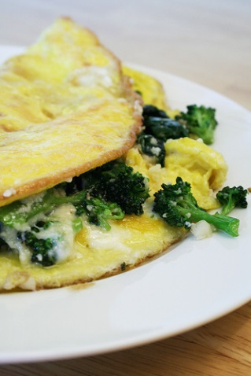
One recipe per 2-3 people

2-3 eggs (one egg per person in group)
25 mL water
15 mL margarine
f.g. salt
f.g. ground black pepper

Fillings: (choose one type per recipe)

- Cheese & Herb – 125 mL grated cheddar cheese, combined with about ½ mL each of chives, basil and parsley OR 2-3 mL Herbes de Provence (a blend of herbs)
- Mexican – 125 mL grated cheddar cheese (you could also use Monterey Jack, if available) + 30 mL salsa
- Italian – 125 mL grated mozzarella cheese + 1-2 mL oregano + 30 mL tomato sauce

- Prepare filling.
- With a fork, lightly beat together eggs, water, salt and pepper.
- In an omelette pan, melt margarine on medium heat.
- When margarine bubbles, add egg mixture.
- When egg is set around the edges, use a heat-resistant rubber spatula/scraper to gently push the cooked part toward the centre. At the same time tilt the pan slightly to allow the uncooked egg to flow in to the empty spaces and under the cooked part.
- While the top is still moist and creamy (not WELL-cooked) place filling over one half of the omelette, or over the middle ⅓ if you intend to attempt a triple fold (as in video).
- Fold in half or thirds as desired, and slide on to a serving plate.
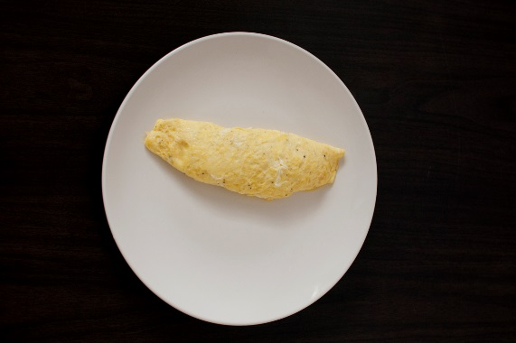
- Serve hot and enjoy!

