GINGERSNAPS

175 mL shortening
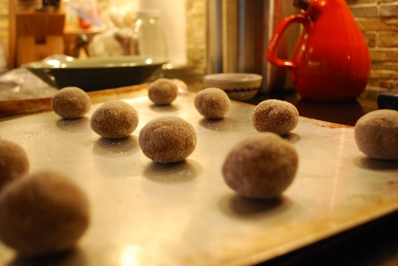
375 mL sugar
80 mL molasses
2 med eggs
750 mL all-purpose flour
15 mL baking soda
3 mL salt
20 mL ground ginger
7 mL ground cinnamon
1½ mL ground cloves

80 mL sugar for rolling

- Place oven racks in centre and one below. Preheat oven to 350ºF (180ºC).

- Grease a baking sheet with shortening or line with parchment paper.

- Cream together the shortening and 375 mL of sugar.

- Stir in the molasses and then the egg.

- Thoroughly combine all the dry ingredients and then blend them into the creamed mixture.

- Form the dough into 2 cm (< 1”) balls and roll the balls in the remaining sugar.

- Place on the baking sheet(s) about 5 cm (2”) apart and bake about 12-15 minutes, or until edges just begin to brown and the tops look cracked. As the balls of dough melt down, the cookies will develop their characteristic texture with the cracked tops. If cooked longer. They will be crispy, rather than soft inside, and they will not flatten as they cool.

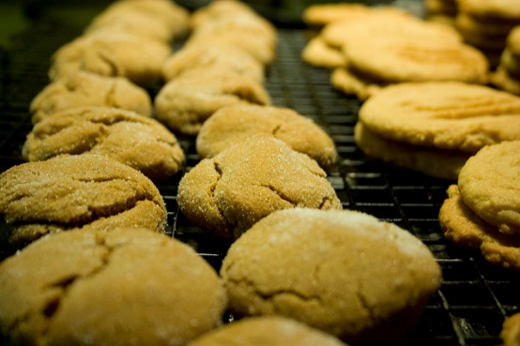
Makes about 4 dozen cookies

Vint Foods 11-12(A) 2016

