SPANAKOPITA
“SPINACH AND FETA TRIANGLES”
SERVES 2-3

INGREDIENTS:
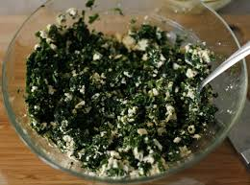
15 mL margarine
⅛ small onion, minced
¼ package frozen chopped spinach, thawed and well-drained
30 mL feta cheese, crumbled
2 mL lemon juice
Pinch ground black pepper
Pinch of dried dill
2 sheets of phyllo dough

30 mL margarine, melted & divided

DIRECTIONS
- Preheat oven to 375°F.
- To drain spinach of excess water: place spinach between 2 paper towels and press together; allowing the paper towels to absorb the excess water.
- Melt 15 mL margarine in a frying pan over medium heat. Add onions and cook, stirring, for about 5 minutes.
- Add spinach and cook for an additional 5 minutes until the juices are evaporated. Remove to a medium bowl and let cool.
- Stir in crumbled feta cheese, lemon juice, black pepper and dill.
- Remove 1 sheet of phyllo dough and brush it lightly with 5 mL melted margarine. Lay the second sheet over the first and brush with 5 mL melted margarine. Cut lengthwise into 6 strips.
- Divide filling into 6 equal portions. Working with 1 strip at a time, spoon ⅙ of the filling at the bottom left corner of the strip. Fold the bottom end over the filling to meet the right-hand edge, making a triangle; press out excess air around filling. Continue to fold, as if folding a flag, all the way to the top.
- Place on baking sheet. Repeat with remaining strips. Brush the tops with remaining 5 mL melted margarine. Bake until golden brown, about 12-15 minutes.
- Serve hot!!!

