**CHOLE CHAAT**

Serves 4-5 people. One recipe per unit.

**Ingredients:**

250 mL canned chickpeas (save chickpea liquid)

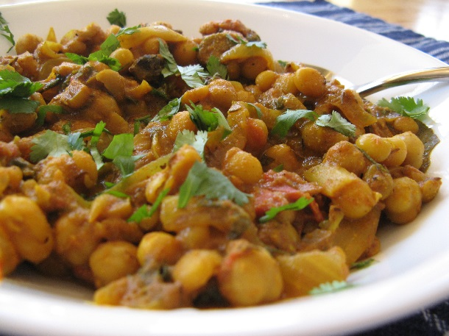30 mL vegetable oil

½ medium onion, **chopped**

15 mL curry powder

5 mL garam masala

2 cm piece of fresh ginger, **grated**

1 red chilli (ex – Thai bird chilli), **minced**

250 mL canned diced tomatoes, **drained**

½ - 1 mL salt (to taste)

**Method:**

1. Remove about 90 mL of the chickpeas and **mash thoroughly** with a fork.
2. Heat oil in a saucepan (a pot) over low heat and cook the onion until it is golden brown. Add curry powder and garam masala. Fry for about one minute to warm spices.
3. Add grated ginger, minced chilli, drained tomatoes and salt (to taste). Stir until well mixed.
4. Add chickpeas (with reserved liquid) and the mashed chickpeas.
5. Bring to a boil over medium to medium-high heat, then reduce the heat immediately and **simmer**, **uncovered**, for about 5 minutes.
6. 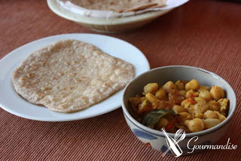Serve with flatbread. Tear off pieces of flatbread and scoop up the curry.

**Fluffy Whole Wheat Flatbread (Paratha)**

Makes 2-3 large or 4-5 small rounds. One recipe per unit.

*When people talk of Peshawar in Pakistan, two things usually come to mind: fragrant basmati rice and the fluffy paratha. Like a croissant, this bread gets its light texture from folding and re-rolling the dough to create layers. For extra flavour, sprinkle finely-chopped ingredients on the dough after the first rolling. They will be incorporated into the dough when it’s rolled again, and will cook briefly with the bread. Try some finely chopped browned onions or a sprinkling of cilantro.*

*The flatbreads of India are not only food, they’re eating utensils. For an informal meal, follow the Indian example and tear off a section of bread to scoop up a chunk of vegetable or meat in its sauce, with perhaps a bit of chutney or raita.*

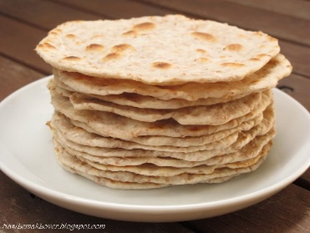

125 mL whole wheat flour

125 mL all-purpose flour

½ mL salt

20 mL vegetable oil, divided

125 mL warm water

vegetable oil or vegetable oil spray, to grease pan

1. Stir together both whole wheat and all-purpose flours with salt. Using hands or dough mixer, blend in half of the oil (7-8 mL). When oil is incorporated, add warm water and mix into a sticky dough. Cover and let rest for 15-20 minutes. Keep remaining oil to brush on dough.
2. Divide dough into 3-5 equal portions. Using a rolling pin, roll out each portion into a thin circle. Use a pastry brush to lightly spread each circle with some of the remaining oil.
3. Dust one round/circle of dough lightly with flour and using a metal spatula or bench scraper, slice from the centre to one edge. Lift one cut edge and roll the dough around the circle, forming a cone shape. Then, press the cone flat, being careful to keep the point in the centre. Roll out again into a thin round. Each person could try rolling their own.
4. **Lightly** grease a heavy griddle, skillet or electric frying pan with vegetable oil (or spray). Preheat for 1-2 minutes at medium heat (275-325ºF for electric pan).Place one or more rounds of dough in skillet (don’t over-crowd) and cook for 1-2 minutes. Flip over and lightly brush top with oil. Cook second side for 1-2 minutes and flip again. Lightly oil second side. Cook until both sides are golden brown.
5. Serve immediately, or wrap several cooked parathas in foil and reheat in 300ºF/150C oven for about 10 minutes or until warm.

