**BRUSCHETTA**

**Serves 2-3**

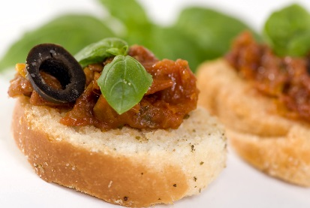1 med Roma tomato, diced small

3 mL dried oregano leaves (or 15 mL fresh)

1 small clove garlic, minced

2-3 slices Italian bread, sliced 1 cm (½”)

(one slice per person)

15 mL olive oil

15 mL parmesan cheese (freshly grated is best)

** Note - If available, a small amount of shredded mozzarella on top is a nice addition (but not traditional) in which case the parmesan could be combined with the tomato mixture. Fresh or dried basil could also be added, to taste.

1. In a small bowl, combine diced tomatoes, oregano and garlic.

Let stand for 10 minutes at room temperature.

1. Preheat oven to 350ºF.
2. Brush bread with olive oil.
3. Divide tomato mixture among bread slices.
4. Sprinkle with parmesan cheese and mozzarella, if using.
5. Bake at 350ºF for 5 minutes.
6. Broil for 1-2 minutes or until golden colour and the cheese melts.

