Foods 9-10(A) – Italy

FOCCACIA – Italian Flatbread
One recipe per 2-3 people

DOUGH TOPPING

250 mL all-purpose flour 15-20 mL olive oil
7 mL instant yeast ⅛ red onion, minced
2 mL salt (regular table salt) 1 lg or 2 sm garlic cloves, minced
2 mL sugar 2 mL dried basil (or 10 mL fresh)
2 mL vegetable oil 2 mL dried oregano
100 mL hot tap water ½ mL dried thyme leaves
f.g. ground black pepper
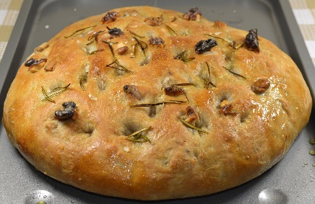
1-2 mL coarse salt (optional – cheese is already quite salty)
15 mL finely grated Parmesan cheese

METHOD:

- Preheat oven to 375ºF. Rack should be in the centre position or (preferably) one below centre.
Grease a pie plate and a small-medium mixing bowl with vegetable oil. Set aside.
Prepare your dough first and work QUICKLY to get the dough resting in the bowl.

- In a large mixing bowl, combine the instant yeast, 2 mL table salt, sugar and 175 mL of the flour. To simplify, just remove approximately 75-80 mL from the 250 of measured flour.

- Check that your tap water is still hot. If not, re-measure or re-heat it. Do not use boiling water as you will kill the yeast. With a wooden spoon, gradually stir the hot water into the flour mixture. Beat well.

- Gradually add enough of the remaining flour to make a soft, but not sticky, dough. It should feel similar in softness to your cheek. Avoid adding too much flour and making a very dry dough.

- Using your hands, knead the dough on a clean, lightly floured surface until smooth and elastic, and small bubbles of gas are seen just below the surface of the dough. Do not add extra flour to the counter if your dough is not sticking or you risk making your dough too dry.

- Form the dough into a ball, place in the lightly-greased bowl and cover with a plate. Let dough rest in a warm place, free of drafts, for 10-15 minutes. The back of the stove-top is a good choice, as it is fairly warm while the oven is on. *Note: If making at home, let the dough rest and rise until it has doubled in size, or even risen then collapsed. This may take up to an hour or more, depending on the temperature of the room and dough.

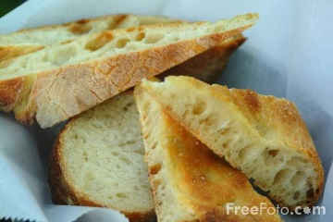

~ Foccacia ~
~ Page 2 ~

- Meanwhile, while dough is resting, prepare your topping. Preheat a small pot on medium-low heat (#3) for 1-2 minutes. Do not leave unattended. When pot is heated, add the olive oil. Add the minced onion and sauté until softened but NOT browned (*tip – use your heat-resistant rubber spatula – you’ll get more of the oil out later!). Just before the onions are done, add the minced garlic. (If the pan is too hot or if cooked too long, the garlic will burn and become bitter.) At the same time, add the basil, oregano, thyme and black pepper. DO NOT add the coarse salt! Continue to sauté for 1-2 minutes more.

- Shape the dough by hand on the pie plate. (Dough does NOT need to fill the sloped sides of the pan.) Dimple the dough with your fingertips, but make sure you don’t make holes right through the dough. Sprinkle/spread the onion mixture, Parmesan cheese and coarse salt (if using).

- Bake for 12-25 minutes or until edges are a pale golden brown, bottom is golden brown and the bread no longer looks doughy (not darker-looking in the centre).

