Foods 11-12(A) Vint
Revised 2017

PASTA PUFFS
One recipe per unit

Divide your tasks so that while one group/person makes the dough,
the other is preparing the pan (heating the oil) and the Honey Syrup.

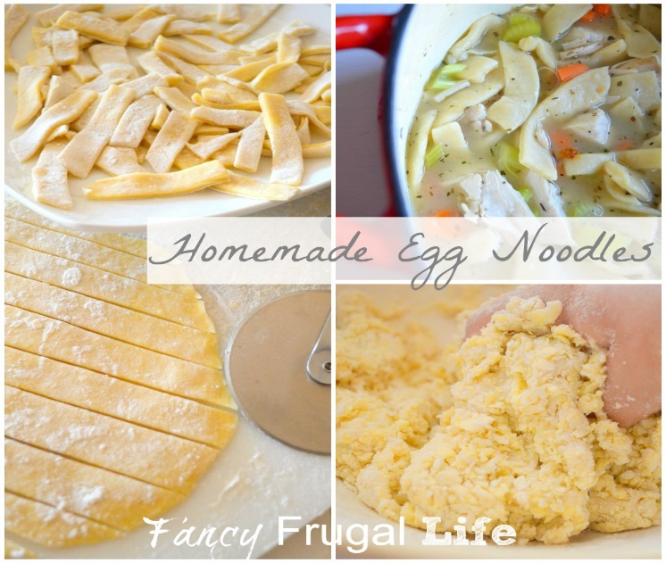

HOMEMADE EGG NOODLES (Pasta all’uovo)
185 mL unsifted all-purpose flour
1 med egg
8 mL oil (olive, if possible)
1 mL salt
Few drops water

- Put 125 mL of the flour into a medium mixing bowl and make a well in the centre. Place egg, oil and salt in the well. Lightly beat together the egg, oil and salt. Start bringing in the flour from the inside edges of the flour pile and mix with the egg mixture. Mix together with the fork until the dough can be gathered into a rough ball. Moisten any remaining dry bits of flour with drops of water and press them into the ball of dough.
- Knead the dough on a lightly floured board or counter, working in the remaining flour ONLY if the dough seems sticky. Do not add extra flour if the dough is not sticking to the board/counter. After 10 minutes of kneading, the dough should be smooth, shiny and elastic. Cover the dough with an inverted bowl and let it rest for at least 10 minutes before rolling it. This allows the water to be absorbed more uniformly throughout the dough.

HONEY SYRUP

In a custard cup or small bowl, mix together the following ingredients:
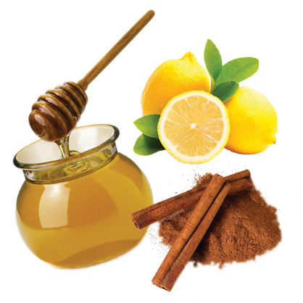
30 mL liquid honey
10 ml hot water
1-2 mL lemon juice

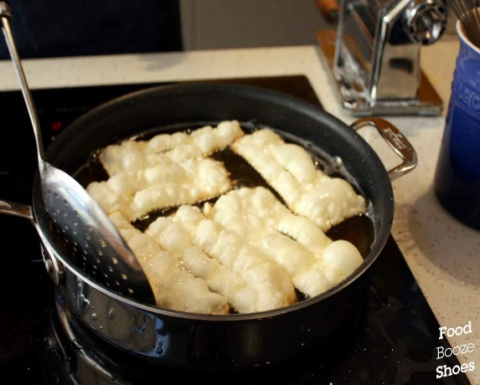
PASTA PUFFS

1 recipe Egg Noodle dough (see above)
Oil for shallow frying
30 mL finely chopped walnuts (optional)
½ mL cinnamon
Honey Syrup

- Preheat oil to 375ºF (190C) in an electric frying pan. The oil should be about 1” (1.5 cm) deep.
- Mix walnuts (if using) with cinnamon.
- Meanwhile, roll dough in the pasta machine until it is in very thin sheets. If the sheets get too long, simply cut in to shorter lengths before running through the rollers again. Cut pasta sheets into rectangles, approximately 5” by 4” (10 x 12 cm).
- Test the oil by carefully dropping a small scrap of pasta dough into the oil. If the oil is ready, upon placing the piece of test dough in the oil, it should immediately begin to bubble up and stay bubbling. Have a paper towel-covered plate ready right next to the frying pan to drain excess oil from fried puffs.
- Fry 2-3 pieces at a time, carefully placing each sheet in the hot oil. Fry for about 5 seconds, or until light golden brown, then quickly, almost in one motion, turn the sheet over and fold it in half. You can use tongs, chopsticks, or even 2 forks (don’t scratch the non-stick pans!). You must do this step quickly! The puffs become crisp rapidly and then they will not fold in half easily. Fry until golden brown, then remove to drain on paper towels.
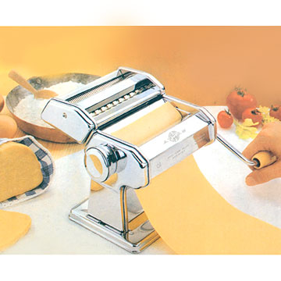
- Transfer drained pasta to a clean plate. Drizzle Honey Syrup over puffs. Sprinkle with cinnamon nut mixture (or cinnamon only). Serve warm.
