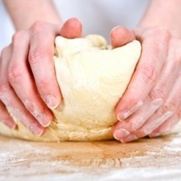
BASIC PASTA DOUGH
Day 1 - One recipe per unit (4-5 people)
4 medium eggs (or 3 large)
500 mL all-purpose flour
Pinch of salt (¼ - ½ mL)

- Measure flour and salt into a med-large mixing bowl. Stir to combine. Make a well in the centre.
- Break the eggs into the well in the centre of the flour.
- Using a fork, gradually pull flour from the sides of the bowl toward the centre until all the flour is incorporated and the resulting dough forms a ball. If the dough is too sticky, add just enough flour to make it easy to handle. If too dry, add a bit of water.
- Knead dough for approximately 2 minutes, until smooth.
- Wrap dough in plastic wrap and place it in a labelled plastic freezer bag for storage. Remove as much air as possible.

Day 2 - USING A MANUAL PASTA MAKER:
Attach the machine to a table edge, securing it with the supplied clamp. Insert the crank handle carefully & gently – line up the handle slots with the grooves inside the opening. Never try to force the handle to turn. Pull out the width regulator knob and turn to adjust the setting. Set dial at #1.

PROCESSING THE DOUGH INTO PASTA:
Divide the dough into 4 pieces. Work with one piece at a time, keeping remaining pieces wrapped in plastic.
Flatten the first piece of dough with your hands so it will just fit through the machine at the widest setting. Begin turning the handle so the smooth rollers turn inward, toward each other and downward in the centre. Begin feeding the dough through the rollers, gently supporting the sheet as it comes out the other side. DO NOT “pull” the noodles out. Rather, gently guide the end outward with your hand so that it doesn’t “bunch up” underneath the rollers. Sprinkle the elongated piece of dough with a little flour and brush off any excess. Fold the dough in half (making it shorter). Sprinkle a little flour on the outsides of the dough and brush off any excess. Pass the dough through the rollers once more at setting #1.
Set the dial to the next number (#2) and pass the dough through again. Sprinkle the dough again with a little flour on each side and brush off any excess. Repeat this process, using progressively thinner roller settings until your pasta is the desired thickness (usually #5-7). Do not sprinkle dough with more flour if it appears to be becoming too dry. NEVER try to force dough that is too dry or hard through the rollers or the handle gears will become stripped.
Repeat this entire process with remaining 3 pieces of dough. Cover rolled dough with a clean tea towel if it looks like it will dry out before you complete all your dough rolling. Sprinkle a few drops of water on the towel.

CUTTING THE PASTA INTO STRIPS:
Attach the cutting rollers by positioning the interlocking guides and pressing down gently at an angle (reverse to remove later). Remove crank handle from smooth roller position and carefully insert into the cutting rollers for the type of pasta you are preparing (fettucine, or wider noodles, in this case).
Cut the first dough sheet into the desired length of noodles. Work with one piece at a time, keeping other pieces covered to prevent drying out. Begin turning the rollers downward toward the centre. Insert one end of the pasta between the rollers and turn the handle slowly, guiding the noodles from under the machine.
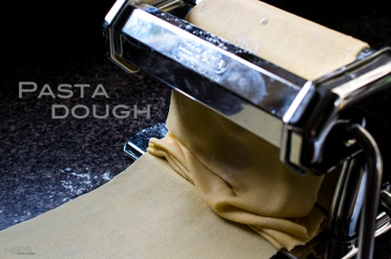
Sprinkle the freshly-cut pasta noodles with some flour and toss, to prevent the strips from sticking together. Toss in a pile, or gather the strands.

CLEANING THE PASTA MACHINE:
Using a DRY cloth and a brush (if necessary), clean the rollers by turning the crank in the opposite direction from rolling the dough (centres of the rollers turn upward) and gently pressing the dry cloth against the rollers.
NEVER wash the machine with water or in the dishwasher.
DO NOT insert knives or anything sharp between the rollers.
Foods 11-12(A) 2016 Vint

