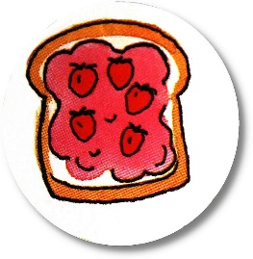
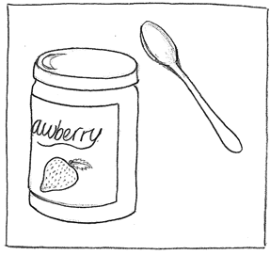
Jam-Making Basics

- Select a mixture of ripe and slightly under-ripe fruit. About ¾ ripe fruit to ¼ slightly under-ripe fruit is a good ratio. This provides more pectin and better texture.

- Rinse or wash the fruit briefly under running water. Do not allow the fruit to soak in water for long periods of time.

- Prepare the fruit as directed in the recipe (peel and/or chop or crush) and measure the fruit AFTER it is prepared. Some recipes call for pre-cooking hard fruits (such as pears) or stone fruits (such as peaches) briefly in water or in their own juices. Others require you to leave the fruit and sugar to stand for a short time to allow juices to form.

- Bring the jam to a boil. Count the cooking time from the moment that the jam starts to boil vigorously.

- Once the jam starts to boil, it should be stirred often to prevent pieces of fruit from sticking to the bottom of the pot.

- Cooking times for jam may vary in minutes, depending on the type of fruit and the amount of pectin present. Most jams are ready when the jam holds its shape somewhat on a spoon. It will thicken more as it cools.

- A candy thermometer is useful to indicate when the jam is cooked. The stage is between 218º and 222ºF (103º and 105ºC). This varies slightly depending on the pectin content of the fruit. A good median figure is 220ºF (104ºC). Adjustments may also need to be made for altitude. You do not have to be as precise with jam as you do with jelly.

- When the jam is cooked, remove it from the heat immediately. Stir and skim off any foam that has collected on the surface of the jam (a metal spoon with a shallow bowl does the best job of this). To reduce the amount of foam somewhat, add ½ tsp. (2½ mL) of butter to the fruit and sugar mixture before it starts to boil.

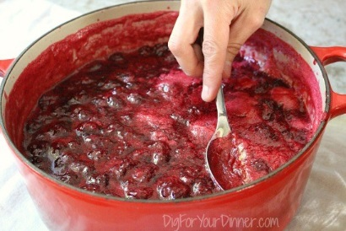

- Some recipes call for stirring the jam briefly (2-5 minutes) to help prevent pieces of fruit from rising to the surface and floating at the top of the jam. This is usually the case with jams that are made from hard or stone fruits.

- Carefully pour or ladle the hot jam into the hot, sterilized jars. You can use a small pitcher or measuring cup for pouring; a ladle and canning jar funnel are more useful for thicker jams. Sterilize ALL utensils that will touch the jam beforehand by placing them in the boiling water along with your preserving jars.

- Leave a ½-inch (1¼ cm) head space at the top of the jars. Carefully wipe the rims of the jars to ensure that there is no spilled jam that might interfere with a good seal. Use a clean cloth or paper towel dipped in hot water (you can use the water from the pot that held your jars).

- Seal the jars according to the manufacturer’s directions.

- Process (boil) the jars in a boiling water bath for 10 minutes (or according to a tested recipe from a trusted source).

****************************************************************************************************

Hint: Safeguard yourself from burns!

Sweet preserves tend to bubble up and spatter during cooking. Use a long-handled spoon and wear oven mitts, rubber gloves or clean cotton gardening gloves to protect your hands and wrists.

Accidents can happen! The risk of burns from splashes can be minimized by wearing long-sleeved clothing – no shorts or sandals, either!

