Name __________________________
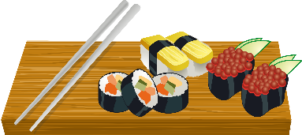
Block ________ Unit _______
JAPAN – VOCABULARY AND QUESTIONS
- Define the following words:
  - Udon
  - Ramen
  - Soba
  - Shichimi
  - Yakumi
  - Yakitori
  - Kushi
  - Oden
  - Yatai
  - Sashimi
  - Daikon
  - Kyuri
  - Wasabi
  - Tempura
  - Nasu
  - Shiitake
  - Tentsuyu
  - Sukiyaki
  - Shabu-shabu
  - Unaju
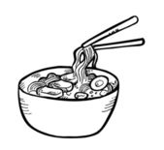
  - Doyo-no-ushi-no-hi
- Is it acceptable to “slurp” your noodles in Japan? Explain.

- How are eels usually prepared and served?

- How is yakitori cooked?

- What are some examples of food served as sashimi?

- Sashimi is very popular in Japan. What special care should be used in preparing and serving sahimi?

- Which foods do you think might be less expensive to but in a restaurant in Japan? Why?

Most expensive? Why?

