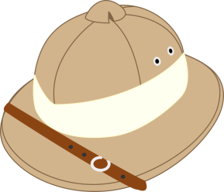
NAME: ______________________________
BLOCK: _________ UNIT: _________
KITCHEN SAFARI

Take a journey! Explore your kitchen and the foods room, searching for the following items you will need during a cooking lab. WASH your hands BEFORE touching any utensils, equipment or dishes!!

- What is your kitchen unit number? ___________
- Where are the cleaning supplies (soaps, cleaners) kept in your kitchen? ______________________
________________________________________________________________________________
- Where are the aprons kept? _________________________________________________________
- Find the dry measuring cups and list the sizes in mL. _____________________________________
Describe where you found them (which drawer?) ________________________________________
Find the measuring spoons and list the sizes (mL) ________________________________________
Describe where you found them. _____________________________________________________
- What staple (most commonly used) ingredients can you find in your kitchen unit? (Hint – there are 8)
________________________________________________________________________________
________________________________________________________________________________
- Where are the CLEAN dishcloths and tea towels kept? ____________________________________
Where do you put them after your lab? ________________________________________________
- Where are the brooms and dustpans kept? _____________________________________________
- Do your oven and microwave have a timer? ____________________________________________
Set them for 5 minutes and watch the clock to see if you set them correctly. Turn them off after.
- Where is the hand soap in your unit? __________________________________________________
What do you use to dry your hands? How many? ________________________________________
Where are they? __________________________________________________________________
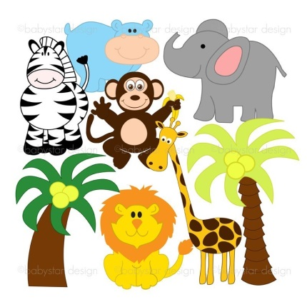

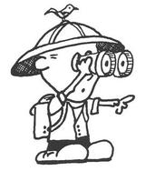

…/2
Page 2

- Where are the “non-staple” food items found during a lab? _______________________________
What do you use to carry the food supplies back to your unit? _____________________________
Where is that located in your unit? ___________________________________________________
- Where are the frying pans in your unit? ________________________________________________
- Is there a garbage can in your unit? ___________________________________________________
What items should go in the garbage can? _____________________________________________
- Where should you put organic waste (veg scraps, etc.)? __________________________________
Where is that located? _____________________________________________________________
- What goes in the blue recycling box? __________________________________________________
- Where should you put used paper towel that is food-soiled? _______________________________
- Where should your washed dishes drain before towel-drying them? _________________________
- How many sets of mixing bowls are in your unit? ________ How many bowls per set? _________
Where did you find them? __________________________________________________________
- How many baking (cookie) sheet pans are in your unit? ___________________________________
Where did you find them? __________________________________________________________
- What is meant by the term “cutlery?” _________________________________________________
Where did you find this in your unit? __________________________________________________
- Where are the electric mixers in your unit? _____________________________________________
- Are there placemats in your unit? ________ If yes, where? ________________________________
- Where are the plates and glasses? ____________________________________________________
- What will your use to protect your hands from burns? ____________________________________
Where are they? __________________________________________________________________
