Foods 9/10 (B)

**C:\Documents and Settings\mv12438\Local Settings\Temporary Internet Files\Content.IE5\0PVMZ321\MC900355939[1].wmfMexican Sugar Cookies (Polvorones)**

Polvorones are a type of heavy, soft and very crumbly Spanish shortbread cookie.

From “polvo,” the Spanish word for “dust.”

**Focus: using the electric mixer. One recipe per unit.**

125 mL margarine

60 mL icing sugar (also known as confectioners’ or powdered sugar)

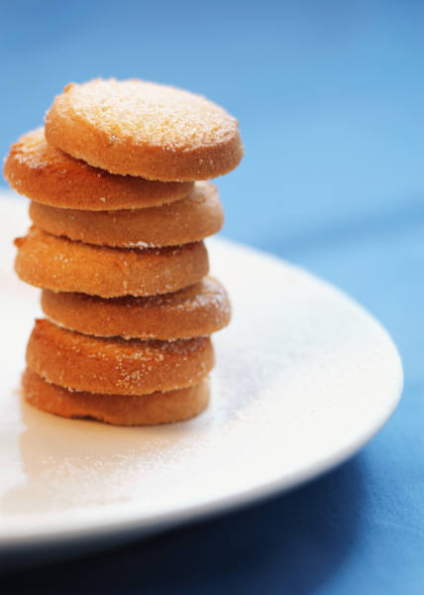15 mL milk

2 mL vanilla extract

2 mL cinnamon, ***divided***

225 mL sifted all-purpose flour

2 mL baking powder

15 mL sugar (a.k.a. white or granulated sugar)

½ square semi-sweet chocolate, grated

1. Preheat oven to 375⁰F. Lightly grease a baking sheet with shortening.
2. Beat margarine in a medium mixing bowl to soften. Beat in icing sugar, starting at slow speed and increasing speed gradually. Add milk, vanilla and **1 mL** of the cinnamon at slow speed. Stop occasionally to scrape down the sides of the bowl. Continue mixing until the mixture is light and fluffy.
3. Stir together flour and baking powder. Gradually add the flour mixture to the margarine mixture at slow speed. If the dough is too soft to shape, stir in an additional 25 mL of flour with a wooden spoon until soft dough is formed.
4. Roll tablespoons of dough into balls about 1¼“ (3 cm) balls - a little smaller than a ping-pong or golf ball.
5. Place cookie balls about 3 inches (7-8 cm) apart on the greased cookie sheet. Using the bottom of a dry measure or a water glass dipped in flour (smooth glass only), flatten each ball into 2-inch (5 cm) circles.
6. Bake in preheated oven about 20-25 minutes or until edges are golden brown. Let stand to cool slightly on cookie sheets for about 3-4 minutes. Don’t cool completely or the sugar mixture will not stick.
7. Meanwhile, combine/stir together the granulated sugar, grated chocolate and remaining 1 mL of cinnamon in a small bowl.
8. C:\Documents and Settings\mv12438\Local Settings\Temporary Internet Files\Content.IE5\FLVJRSD3\MC900304957[1].wmfWhen cookies are **slightly** cooled, carefully/gently transfer them (one at a time) using a metal spatula or tongs to the sugar mixture. Coat with sugar on both sides. Carefully remove the cookies (with tongs or metal spatula) to wire racks to cool completely.

C:\Documents and Settings\mv12438\Local Settings\Temporary Internet Files\Content.IE5\TW5B5E4X\MC900001364[1].wmf