**MeXico**

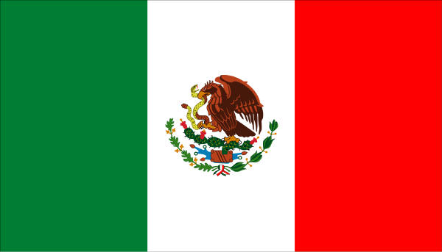**Location**

The country of Mexico lies to the South of the United States where the two countries share a 2,000 mile border which stretches from California to Texas. Mexico’s population is around 123 million and increasing rapidly. Nearly one third of Mexico’s people live in the 3 main cities: Mexico City, Monterrey and Guadalajara. Many people who were born in villages are moving to towns and cities in search of work and overcrowding is becoming a problem in some places.

**(GREEN)N**

**(RED)**

**Introduction**

When North Americans visit Mexico, they often see only the towns just across the border with their souvenir shops and fast food stands. These people never get a glimpse of the real Mexico which is a large, rich and complicated country that stretches for a thousand miles beyond the border it shares with its neighbour.They never get a chance to sample the true goodness of real Mexican food.

**The land and the people**

The 31 states of Mexico are spread out over a vast land nearly as varied in climate and geography as the rest of the world put together. There are rocky deserts, mountains shrouded in mist, steamy rain forests and fertile plains. All of these can be found in Mexico, often within the same geographical region.

The lives of Mexican people in the large cities are almost as varied as the country’s landscape and climate. Many Mexicans work in modern office buildings and live in comfortable apartments while others make their homes in crowded slums. The capital, Mexico City, is the second largest city in the world and has most of the problems that plague big cities everywhere, including traffic jams and air pollution. Outside the capital, there are smaller, less crowded communities like Oaxaca (wah-HAH-kuh) where air is clean and life is less hectic. In these towns, flowers bloom on the patios of whitewashed houses and young people still take the traditional walk around the central plaza each evening at sunset. Even farther from the bustle of the big city, Indian farmers in the states of Yucatan and Chiapas live in thatched-roof houses and go to work each day in the corn fields, using the same kinds of tools that their ancestors used a thousand years ago.

C:\Users\Vint\AppData\Local\Microsoft\Windows\Temporary Internet Files\Content.IE5\EG73OV9M\MC900183504[1].wmf C:\Users\Vint\AppData\Local\Microsoft\Windows\Temporary Internet Files\Content.IE5\N3PT1A0Y\MC900183506[1].wmf

A thousand years ago, the country that is now Mexico was inhabited by groups of Maya Indians who had a very advanced civilization. By the time that soldiers and explorers from Spain arrived in Mexico during the early 1500s, another powerful group of Indians, the Aztecs, ruled the land from a great city called Tenochtitlan (tay-nosh-tee-TLAHN), located where Mexico City now stands. These Spaniards conquered the Aztecs, destroyed their capital city and took possession of their land. From this harsh beginning, the modern nation of Mexico was born.

Today, most Mexicans are descended from both Spanish and Indian ancestors. They are called *mestizos* (mes-TEEZ-ohs), which means people of mixed blood, and they have inherited the customs and traditions of two very different civilizations. The food of Mexico is a fascinating blend of these two rich traditions.

**Indian + spanish = mexican**

C:\Users\Vint\AppData\Local\Microsoft\Windows\Temporary Internet Files\Content.IE5\9G1WYC0I\MC900435442[1].wmfThe Indians of ancient Mexico ate many foods that were unknown to Europeans in the 1500s and today these foods are still an important part of the Mexican diet. Among them are corn, tomatoes, squash, avocados and many varieties of beans and peppers. Another food that ancient Mexicans gave to the world was chocolate, which had a very special meaning to the Aztecs and other Indian civilizations. Cocoa/chocolate beans were sometimes used as money and the bitter drink made from them was considered sacred and reserved only for priests and rulers. Chocolate sweetened with sugar is now popular all over the world but the people of Mexico have a special fondness for it.

C:\Users\Vint\AppData\Local\Microsoft\Windows\Temporary Internet Files\Content.IE5\H2GF2FA4\MC900233494[1].wmfOf all the foods native to Mexico, corn is the most popular and most important, today as in the past. The corn tortilla (tor-TEE-yuh), a kind of thin, flat pancake, accompanies almost all Mexcian meals, either as bread or as part of the main dish. A versatile food, the tortilla can be toasted or fried, rolled or folded, stuffed with meat or vegetables, or topped with rich sauces. Many modern Mexican cooks make their tortillas from specially prepared dough called masa or buy them every day from tortillerias (tor-tee-yuh-REE-uhs), stores that sell freshly made tortillas. In some rural areas of the country, however, tortillas are still made in the age-old way.

Another native food essential to Mexican cooking is the chilli (CHEE-leh), or pepper. Relatives of the green or bell pepper family in North America, Mexican chillies come in many sizes, colours and flavours. Some are more than 12 inches long, while others are little larger than a bean. When they are fresh, chillies are usually various shades of green and yellow. When they become ripe, most of them turn bright red or orange. Many chillies have a sweet, mild flavour but some are so hot that they would make your eyes water just to smell them. These fabulous peppers have beautiful names like jalapeňo (hah-lah-PEH-nyoh), poblano (poh-BLAH-noh), and serrano (she-RRAH-noh) and they are used to give a special flavour to a great variety of Mexican dishes.

Mexican cooking also depends on many ingredients that are not native to the country but were brought from Europe by the early Spanish settlers. Beef, chicken and pork are European contributions to the Mexican table. Rice and wheat also came from Europe, as did spices such as cinnamon and cloves. Because of their European heritage, modern Mexicans enjoy apples and peaches in addition to papaya, mangoes and other tropical fruits known to their Indian ancestors.

**At the mercado**

When Mexican cooks shop for fruits, meats and vegetables needed for the dishes on their menus, they often go to an open-air Mercado (mer-KAH-doh), or market. Busy markets can be found in the villages and towns of the Mexican countryside as well as in big cities likeC:\Users\Vint\AppData\Local\Microsoft\Windows\Temporary Internet Files\Content.IE5\9G1WYC0I\MC900056463[1].wmf Guadalajara and Mexico City. Shoppers make a selection from a tempting variety of fruits and vegetables arranged in neat piles on stands or on the ground. The air is heavy with the fragrance of ripe fruit and the sharp smell of green herbs like cilantro (see-LAN-troh), or fresh coriander, a popular seasoning. Shoppers quietly bargain over prices and fill their net bags with purchases that will become part of the day’s meals.

Markets like these have existed in Mexico for centuries and they are still an important part of Mexican life. In some large cities, there are *supermercados* (supermarkets) where canned and frozen food can be obtained but many Mexican cooks make a daily trip to an outdoor market to buy fresh fruits and vegetables. Homes in rural areas of Mexico often have no refrigeration, so food can not be stored for very long. Even when storage is possible, many Mexican cooks believe that food tastes best when it is prepard fresh every day.

C:\Users\Vint\AppData\Local\Microsoft\Windows\Temporary Internet Files\Content.IE5\N3PT1A0Y\MC900104364[1].wmf**Mexican festivals**

C:\Users\Vint\AppData\Local\Microsoft\Windows\Temporary Internet Files\Content.IE5\H2GF2FA4\MC900098067[1].wmfMexican festivals are a swirl of colour and gaiety. Each village celebrates the anniversary of at least one patron saint. It may be the saint for whom the village or church was named or a saint who is said to have visited the village long ago. Whatever the reason, everyone puts on their best clothes and flocks to the main square where they dance, sing and have fun long into the night. Sometimes the festivals can last for three days and nights, and the Mexicans enjoy every minute of it!

Christmas is the longest holiday in the Mexican calendar. The festivities begin on December 16 and last through Epiphany, or Twelfth Night, on January 6th. Among the celebrations, Christmas Day and Epiphany are the special family occasions. On these days the whole family, which is often quite large, will get together to celebrate.

**Regional cooking**

Certain foods, such as tortillas, tomatoes, onions, garlic and chillies are used for cooking throughout Mexico. The town of Puebla has become famous for its *mole Poblano*, a savoury chocolate sauce derived from an old Indian recipe that is served with chicken or turkey.

Most of Mexcio’s beef is produced in the Northern states. Monterry is renowned for its excellent beef and goat meat. Traditionally, food in this area is heavy and very filling. The ranch workers need three hearty meals each day, often beginning with *huevos rancheros*, or ranch-style eggs, that are served with beans, avocado and tortillas.

Fish and seafood have always played an important part in the Mexican diet. Montezuma, the Aztec Emporer, had fresh fish brought to his court in what is now Mexico City by runners from the seaport of Veracruz. Both the Pacific and Gulf waters are rich in seafood. The gulf of California has wonderful oysters and abalone, while the gentle East Coast waters procide many kinds of fish, crabs, lobster and shrimp.

**Corn**

Corn, also known as maize, is an important crop all over the world, ranking second only to wheat. In Mexico, it is the most important food crop, occupying half of the total cultivated land area. The word *maize* comes from the old Indian word *mahiz*.

In towns, people are beginning to eat more meat, vegetables and fruit, and less cornbut in the rural areas corn is still very much the staple food.

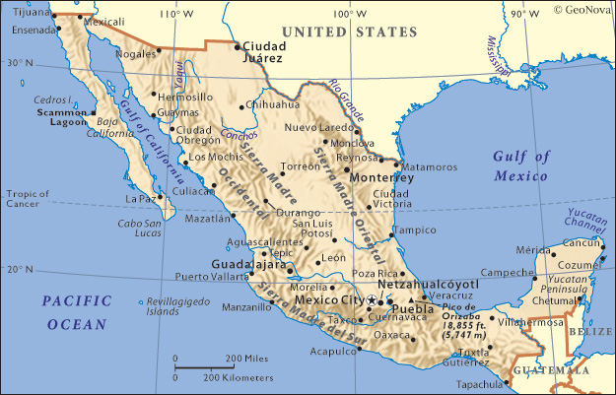

**Name:** ­­­­­­­­­­­­_______________________

**Block:** _________ **Unit:** ________

**MEXICO WORKSHEET #1**

Use “Mexico” handout to complete questions.

1. The population of Mexico is: _______________________________________________________
2. Where do one-third of people in Mexico live? _________________________________________

_______________________________________________________________________________

1. Today, most Mexicans are descended from both ___________________________ and ___________________________ ancestors.
2. The diet of the Indians of Ancient Mexico consisted of ________________, ________________, __________________, _________________, _________________, _________________, and _______________________________, which originated in Mexico and are a national favourite.
3. The most important crop is __________________, which is used to make thin, flat pancakes, called ____________________. What are the different ways this item can be prepared?

____________________________________________________________________________

____________________________________________________________________________

1. The other native food that is used extensively in Mexican cooking is _____________________. Name two varieties: ___________________________ and _____________________________.
2. When chillies ripen they change color from green and yellow to ______________________ and ______________________.
3. Name the foods that were brought to Mexico from the Europeans:

_____________________________________________________________________________

_____________________________________________________________________________

1. The name for the open air market where Mexicans love to shop is _______________________.
2. Why do most Mexicans prefer to shop daily at these open air markets instead of supermarkets?

______________________________________________________________________________

______________________________________________________________________________

1. Mexican festivals revolve around celebrating the anniversary of __________________________.
2. What is “mole poblano” and what is it served with?

______________________________________________________________________________

1. What is “huevos rancheros” and who is it popular with?

______________________________________________________________________________

1. Name the longest holiday in Mexico: ­­­­­­­­­­­­­­­­­________________________________________________.
2. Which foods are used in everyday cooking?

______________________________________________________________________________

______________________________________________________________________________

1. The state of Monterrey is well known for these two meats: ______________________________________________________________________________
2. Name some of the types of seafood available on the Pacific and Gulf waters:

______________________________________________________________________________

1. __________________________ had a very special meaning to the Aztecs and was sometimes used as money.