Foods 11-12(A) 2017

BAKLAVA TRIANGLES
One recipe per unit (makes 12 pieces)

150 mL walnuts
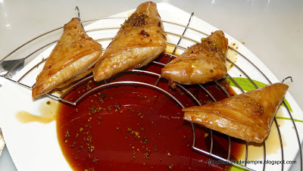
75 mL slivered or sliced almonds
15 mL berry sugar (superfine or caster sugar)

100 mL white/granulated sugar
100 mL water
10 mL honey
5 mL lemon juice
f.g. ground cloves (to taste – a strong flavour)
7 mL ground cinnamon

3 sheets phyllo pastry
40 mL butter or margarine (unsalted or salted), melted

- Preheat oven to 375ºF. Cover a baking sheet pan with foil and lightly grease with butter or margarine. Alternatively, use parchment paper if available.
- Finely chop the walnuts and almonds. In a medium bowl, mix together the nuts and berry sugar (15 mL).
- In a small saucepan (pot), mix together the white/granulated sugar, water, honey, lemon juice, cloves and cinnamon. Bring to a boil over high heat and boil for 10 minutes or until it is the consistency of runny honey. (Reduce heat if it looks like it will boil over or burn!) Stir often. If the syrup cooks TOO long, it may become brittle upon cooling.
- Remove the sugar syrup from the heat and pour over the nut mixture. Mix well with a wooden spoon. Allow to sit for a few minutes to cool slightly.
**NOTE: Be very careful not to get hot sugar syrup on your skin!
- Cut phyllo pastry into 4 strips, lengthwise. Remember that phyllo pastry is very fragile and must be kept covered at all times until you are ready to use it, to prevent drying out. Work with only 1 or 2 strips of pastry at a time.
- Lightly brush each strip with melted butter or margarine. Using teaspoons, place 1/12th of the filling on one end of each strip. Fold as demonstrated to form triangles. Each student should practice folding at least 1 or 2 triangles.
- Place pastries on prepared pan and lightly brush the top of each with melted butter or margarine.
- Bake for 10-12 minutes or until golden brown. Serve warm or cold.
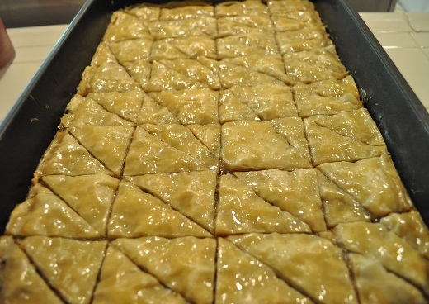
*Note - Traditional baklava is layered in a square or rectangular cake pan and then cut into triangle or diamond shapes before baking. These triangle “packets” are more portable and easier to eat as a “finger food.”

