Textile Studies 8 Name: ______________________

Blk/Mach#: ____ /_____

Pencil Case (PC) Assignment

Settings for Straight Stitching
WRONG
SIDE OF
FABRIC
Pattern Selector Dial – A1
Zigzag Width Control – 0
LABEL WITH: NAME,
BLOCK,
MACHINE #
Stitch Length Control – 2.5

Settings for Zigzag Stitching
RIGHT
SIDE OF
FABRIC

Pattern Selector Dial – A3
Zigzag Width Control – 5
Stitch Length Control – 1.5

Zigzag reminders: Position the edge of your fabric under the needle so the fabric is almost covering the 1/8” guideline on the bobbin cover plate. This will ensure your needle will drop off the edge of the fabric on the right side of the zigzag stitch to overcast the raw edge.

A successful sewer will: 1. Read and look over all instructions and diagrams before beginning.
2. Look over all the PC samples on the wall before beginning.
3. Remember to “ask 3 before me” (teacher).

PROJECT INSTRUCTIONS:

- Finishing Raw Edges - Set your machine for zigzag stitching. Zigzag stitch along the edge of the
TWO (both) short sides/ends of your fabric. Backstitch 1 cm at each end of stitching. Trim threads. See the left side of “Diagram A” below.

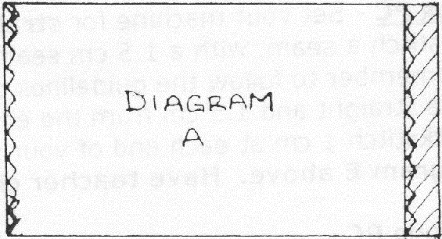
Backstitch 1 cm

Step 2:
Fold
BOTH
ends 3 cm

Step 1:
Zigzag
BOTH
ends

LABEL WITH: NAME,
BLOCK,
MACHINE #

Backstitch 1 cm

3cm

- Pressing - Place your fabric wrong side facing up (the side you wrote your name, block, &
machine #) on a hard, flat surface. Using a seam gauge to assist you in measuring, fold fabric over 3 cm along the short side/end of your PC towards the wrong side and crease with your fingers. Push pins (3) in & out through both layers to maintain fold. Repeat with the other short side/end of your fabric. Press folded edge with a hot, steamy iron to get a sharp crease.
Measure the pressed edge to see if it is still 3 cm. Re-measure and press again if incorrect.
See the right side of “Diagram A” above. Have teacher check/mark.

- Page 2 -

3. Attaching Velcro –
*NOTE: “Velcro” is a brand name for a type of fastener that is generically referred to as “hook and loop tape.”
Get a piece of Velcro from your teacher (4 cm shorter then the width of your fabric). Centre
(top/bottom and side to side) the loop piece of Velcro along one folded edge of your PC and pin it down. Make sure the pins are inserted down through the Velcro and the two fabric layers (in through ALL layers) and then back up through the two layers and the Velcro (out through ALL layers). Repeat with the hook piece of Velcro along the other folded edge of your PC. See “Diagram B” below. Have teacher check/mark.

3 pins:

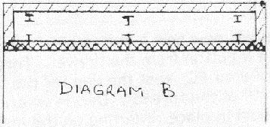

Push pins “IN” and “OUT” through ALL layers!

4. Sewing Velcro - Set your machine for straight stitching. Begin stitching along the right
side/end of the Velcro (along the narrow side). Stitch close to the edge of the Velcro. Along the length of your Velcro place the edge of your presser foot along the edge of the folded down flap of fabric to maintain a straight line (as long as you have folded accurately).

DO NOT sew over the pins! Remove pins as the presser foot reaches each one. Remember to “PIVOT” at each corner and backstitch 1 cm when you begin and end stitching. Leave NO GAPS in the seam. Trim threads. See “Diagram C” below. Have teacher check/mark. Stitch the other piece of Velcro in place the same way on the other end. Trim threads.

Start and end sewing here.
BACKSTITCH at the beginning and the end.
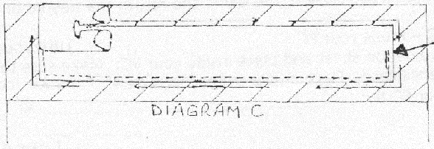

- Page 3 -

5. Shaping Your PC - Fold fabric in half width-wise, right sides together (Velcro is facing out). Make sure the top and side edges of your PC are even. See teacher if fabric won’t lie flat when corners are matched. Next, place pins in the 4 corners to secure the top and bottom edges. Then place 2 more pins along each outer edge of your PC. Remember to place pins perpendicular to the seam line. Recheck that the top and sides are even. Re-pin if they are uneven.
See “Diagram D” below.

Top edges

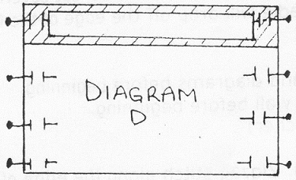
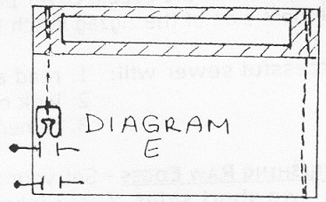

Side
edges

6. Sewing Your PC - Set your machine for straight stitching. Start at the upper edge (velcro end) and
straight stitch a seam, with a 1.5 cm seam allowance, along both sides of your PC to the bottom edge. Remember to follow the guidelines on the bobbin cover plate and throat plate to keep your seam line straight and 1.5 cm from the edge of your fabric. Remember: DO NOT sew over the pins. Backstitch 1 cm at each end of your seams. Trim threads.
See “Diagram E” above. Have teacher check/mark.

7. Finishing Your PC - Using a seam gauge as a guide, trim (cut) seam allowance, leaving a 1 cm seam
allowance along each side of your PC. Set your machine for zigzag stitching. Zigzag stitch along one edge of your PC (along the seam allowance you just trimmed to 1 cm). You will be sewing through 2 layers of fabric. Backstitch 1 cm at each end of stitching. Trim threads. Repeat for the other side of your PC. See “Diagram F” below.

Turn your PC right side out. Make sure corners are pushed ALL the way out. Use the corner of a ruler (or some other NON-SHARP item) to make sure corners are square.
Press flat with hot iron and steam. Have Teacher check and mark.

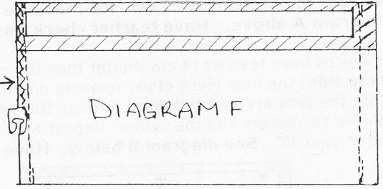
Backstitch 1 cm

Zigzag should Zigzag this
overcast edges side, too!

Backstitch 1 cm

Trim to 1 cm Trim to 1 cm

- Page 4 -

8. Hand Sewing A Button - You will now sew a button onto one side of your PC.

Choose a button from the drawer. Cut a piece of thread about one arms-length long. Thread a hand-sewing needle with the thread and pull it through enough to fold in half and match the ends. Knot the 2 ends of the thread together. Try not to allow the thread to become too twisted.

Watch the video demonstration of sewing on a button.

Decide where you want to attach your button on the right side of your PC and hold it in place. Starting on the outside (the “right” side) of your PC, push your needle through your button and PC to the inside (the “wrong” side). Push the needle back out/up (starting only a very small space away from where it first came through) and through one of the holes in your button. The knot in your thread will be under the button. Repeat through the other hole in your button to the wrong side of your PC. Be careful to keep the stitches all directly under the center of your button on the wrong side of your PC and make sure you pull the thread – both layers - all the way through the fabric and button each time you sew through the button holes. Check for loose loops of thread each time you make a stitch. Pull each stitch snug but not too tight.

Continue sewing, making “loops” through the button until you have sewn through each button hole 4-5 times. If you have a 4-hole button, repeat the entire process through the other set of 2 holes. For the final stitch, push the needle up toward the right side, but this time, come up UNDER the button without going through the button hole. To add extra strength and to lift the button slightly away from the fabric, make a “thread shank” by winding your thread 3 times around the threads under the button. Then take one final, small stitch under the button to anchor the thread shank.

Neatly and securely tie off your thread on the right side of your PC, under the button (“fold” the button back a bit) by taking a small stitch through the fabric and drawing the needle up through the loop of the stitch before pulling the thread tight. Repeat 3 times. Trim the thread close to the fabric (leave a ¼”/5mm tail) and return the needle to the tray/package immediately.

9. Handing In Your PC – Press your PC and trim all loose threads. Turn your PC inside out. Fold the
evaluation sheet in half and place inside your PC. Make sure that your name is on the evaluation sheet AND your pencil case. Place in pile on teacher’s desk.

Please hand in your PC by: _______________________________

