Peppermint Meringue Cookies
"Crunchy minty Christmas cookies!"
One recipe per unit

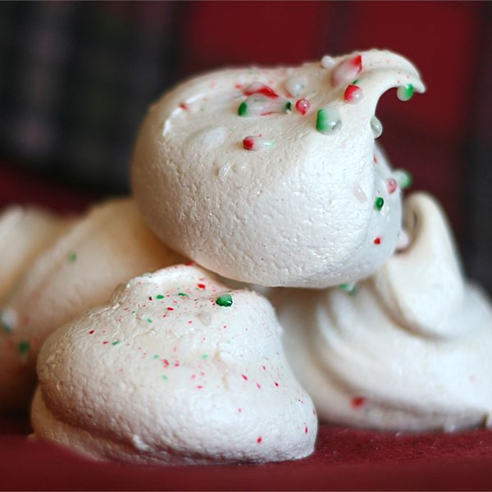
Ingredients
- 2 egg whites (or 50-60 mL liquid egg whites)
- 5 mL cider vinegar
- ½ mL salt
- 1-2 drops red food colouring (optional)
- 1-2 drops peppermint extract (optional)
- 80 mL white sugar
- 2 peppermint candy canes, crushed

Directions
- Preheat the oven to 225 ºF.
- Line cookie sheets with parchment paper.
- Wash a large metal bowl and beaters for an electric mixer in HOT, soapy water. Rinse thoroughly and dry with a clean towel.
- In the clean, large bowl, combine the egg whites, vinegar and salt to the soft peak stage (slightly past the foamy stage).
- Gradually add the sugar while continuing to whip the mixture until stiff peaks form.
- Fold in the colouring & flavouring (if using) and ⅓ of the crushed candy canes, reserving the rest for sprinkling on top.
- Drop by teaspoonful OR use a piping bag with a star tip OR use a sandwich bag with a hole cut in the corner to pipe small cookies, one inch (2½ cm) apart on the prepared baking pan(s).
** NOTE: It is very important, in class, to make them SMALL, so they have enough time to bake and dry out (think Hershey’s Kisses size, or slightly larger).
- Sprinkle remaining crushed candy canes over the top of the unbaked cookies.
- Bake in the preheated oven for 45-50 minutes, or until dry.
- Cool on baking sheets.
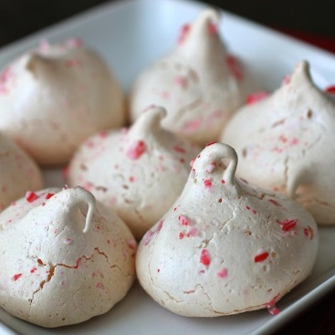
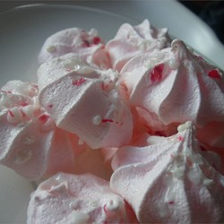

Adapted from a recipe at: http://allrecipes.com/recipe/26208/peppermint-meringue-cookies/

