Name _______________ ___ Block _____

SEWING SAFETY – FIND THE HAZARDS
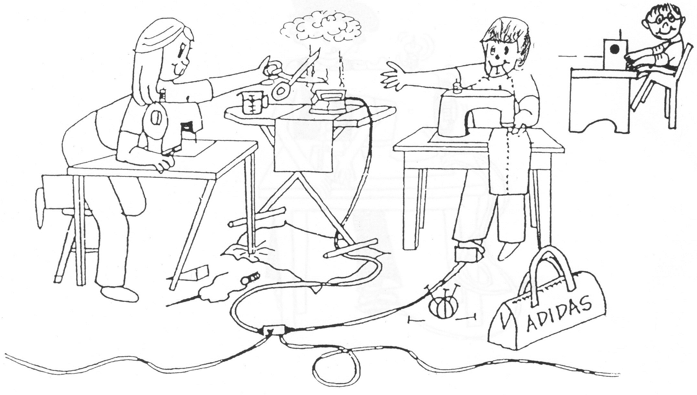
Describe all the safety hazards you can see in this picture:
1
2
3
4
5
6
7
8
9
10
Name _______________ ____ Block _____
SAFETY WHILE SEWING
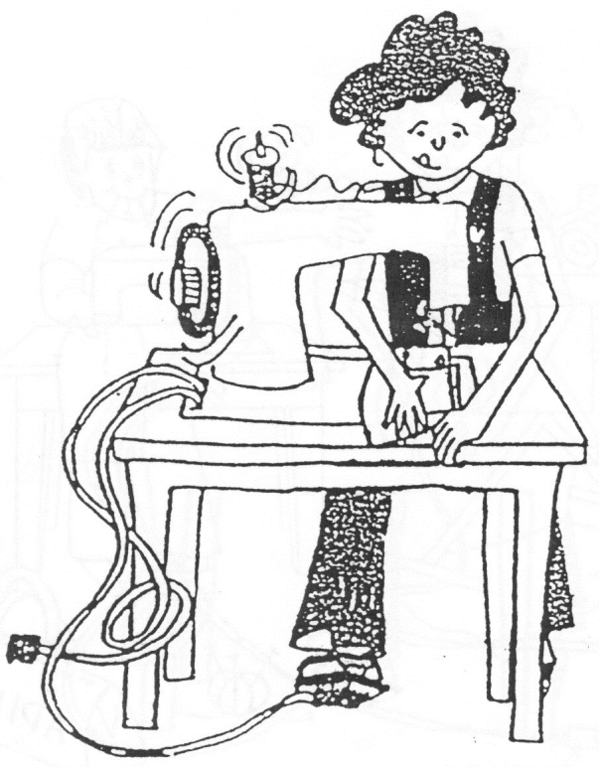
- Clear a traffic path. Put all backpacks and loose or bulky clothing well out of the way.
- Push your chairs in every time you get up.
- Organize your table and put all bags and pencil cases, etc., in your drawer underneath your table top (or wherever your teacher directs if the former doesn’t apply).
- Keep your sewing supplies organized in the tray/bin on your table and return items to their PROPER place immediately when you are finished with them.
- Keep pins out of your mouth – not only are they sharp, but they may be dirty and unsanitary. Pass scissors or sharp objects to others with the handle first.
- Do not have drinks or food at the tables or near the sewing machines. Plain water is okay to keep under your table if you close the bottle immediately after taking a drink. Spills could damage the machines or stain your work.
- Sewing machines should be placed as near to the electrical outlet as possible. Electrical cords must not be in a traffic path and you must be careful to not get them caught in the chair legs.
- Lower the foot pedal gently to the floor in a comfortable position for you to sew. When you pick it up at the end of class, lift it by the box, NOT by the electrical cord.
- Make sure all cords are safe. If a cord becomes frayed or damaged, have it repaired or replaced.
- Keep your chair tucked in while seated and move the machine to a position that feels comfortable.
- FOCUS on the task while at the machine. Keep your mind on your sewing while the needle is moving!
- Keep your fingers well away from the path of the needle while you are guiding the fabric.
- Sew at a SLOW speed until your ability to control the machine improves. Accuracy before speed.
- Do not sew over pins unless they are perpendicular to the seam. Remove pins as you approach them.
- Turn off the machine’s power switch when not in use and EVERY TIME you leave your machine station.
- Clean up fabric and thread scraps around and under your machine. If a cover is available, put it on the machine to keep the dust off if you won’t be sewing for a while.

