BASIC SOUFFLÉ
One recipe per 2-3 people

Using this basic recipe, you can make many different soufflés by varying the seasonings and cheese, or by adding additional ingredients such as various types of shredded cheese &/or chopped vegetables or meats.

High-Rise Tips
- Have eggs at room temperature. If you’re using them straight out of the fridge, cover them with slightly warm water for a few minutes.
- NEVER use a plastic bowl to beat egg whites and make sure that the bowl you use is FREE from grease. Any traces of fat will reduce the volume of beaten egg whites.
- An electric mixer makes beating egg whites until stiff and glossy much easier than doing it by hand with a whisk. DO NOT OVERBEAT or whites will become dry and flaky and won’t hold air.
- For this recipe, it’s unnecessary to extend the height of the dish with a foil or waxed paper collar, as some recipes will suggest.
Fine bread crumbs or Parmesan cheese (optional) or a combination of both
25 mL butter or margarine
25 mL all-purpose flour
125 mL milk
1 mL salt
Pinch ground pepper
125 mL cheddar cheese (Old for more flavour)
Pinch dry mustard
2 eggs, separated
½ mL cream of tartar

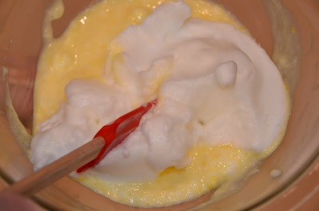

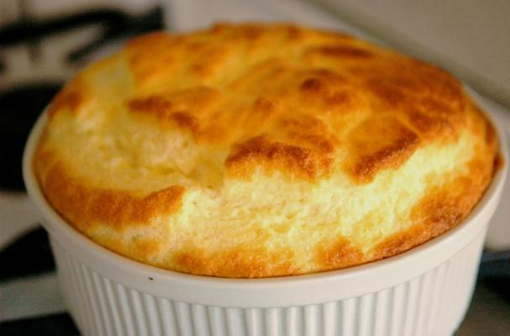

METHOD:

- Preheat oven to 375ºF.
- Grease 2 small casserole dishes OR 1 medium size dish for each recipe.
- Separate eggs, being especially careful that absolutely NO egg yolk contaminates the whites.
- Grate cheese. If making at home, prepare any other ingredients you plan to add.
- Melt margarine in a double boiler, then add flour. This is called a ROUX and it will thicken the milk mixture. Add pepper and mustard (and/or any other seasonings, if making at home). Use of a double boiler will prevent milk from scorching.
- Remove from heat and GRADUALLY stir in milk. Return to heat and cook until JUST beginning to thicken. Mix 2 spoonsful of hot milk mixture into the egg yolks to “temper” them (warm them up, so they won’t cook and become lumpy).Slowly stir the warmed yolks into the milk mixture and cook until slightly thickened. Over-thickening will cause the mixture to be too heavy and the soufflé will not rise to an impressive height. Stir in cheese (and any additional ingredients, if making at home).
- Beat egg whites, adding the cream of tartar at the “foamy” stage. Think of bubble bath or soapy dishwater. Continue beating until whites are stiff but not dry.
- FOLD stiffly-beaten egg whites carefully into the sauce. Try not to break too many bubbles. Pour/scrape the mixture into the prepared casserole dish. For a “top hat” effect, run the tip of a knife gently around the top of the soufflé, about ½ - 1 cm away from the edge of the dish.
- Bake for approximately 12 minutes for a small size casserole dish, or until a paring knife inserted in the centre comes out with no raw egg on it. The top should be golden brown. The larger size dish may take between 15-20 minutes to bake.
NAME: _______________________
BLK: _________
Soufflé Notes

GENERAL PRINCIPLES:

- Fresh eggs and stiffly beaten whites are essential for good volume.
- Collect all ingredients and equipment and preheat oven before mixing.
- Cool mixture before adding egg whites and fold whites in carefully.
- Keep oven closed for at least ⅔ of the baking time.
- Soufflés are cooked when the mixture will not stick to your finger when you press gently on the top.
- Always serve immediately, as the soufflé will collapse as the bubbles contract on cooling.

QUESTIONS:

- What is the purpose of making a ROUX of the fat and flour before adding the milk?
_______________________________________________________________________
_______________________________________________________________________
_______________________________________________________________________
- Why is it advisable to make a white sauce in the top of a double boiler? _______________________________________________________________________
_______________________________________________________________________
_______________________________________________________________________
- At what temperature should high protein foods be cooked? _______________________________________________________________________
_______________________________________________________________________
- What are the major nutrients in a cheese soufflé?
  - ___________________________________________________________________
  - ___________________________________________________________________
  - ___________________________________________________________________
- Of what should you be careful when beating egg whites? _______________________________________________________________________
_______________________________________________________________________
______________________________________________________________________________________________________________________________________________

