Chilled Cucumber and Avocado Soup
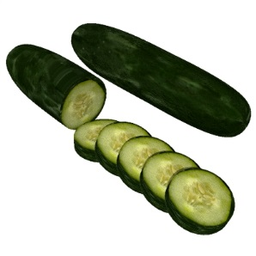
One recipe per unit of 4-5 people

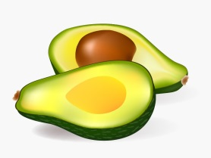
1 large seedless cucumber, peeled and cut into rough slices
Flesh of ½ large Haas avocado
1 green onion (green and white parts included), chopped
15 mL lime (or lemon) juice (preferably fresh, but bottled is okay)
½ to 1 mL sea salt (to taste)
pinch black pepper (or to taste)

** Reserve one thin slice of cucumber per bowl to float on top of soup before serving. **
Blend all soup ingredients together in a blender till smooth, or process with an immersion blender in a straight-sided bowl or pot. Add just enough water during processing to allow the blender to move freely and to achieve a perfectly creamy texture (about 60 mL, but use your judgment).
Serve in bowls, topped with a thin cucumber slice.

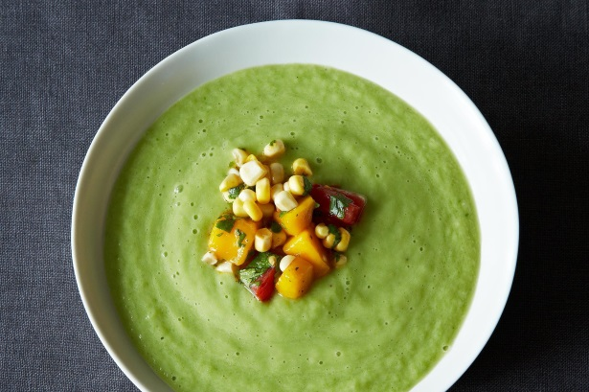

Adapted from a recipe at: http://food52.com/recipes/23524-chilled-cucumber-and-avocado-soup-with-mango-salsa Foods 11-12(B) 2016

