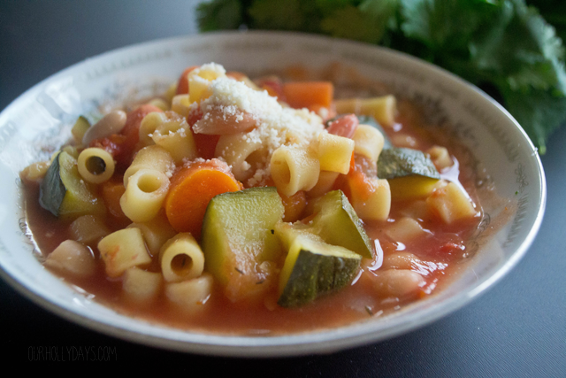

MINESTRONE SOUP

(work in pairs or groups of 3)

Ingredients
- 80 mL each sliced or diced carrots, celery and zucchini
- ½ small or ¼ large onion, chopped
- 5-10 mL olive oil
- 60 mL macaroni or medium pasta shells, cooked and drained
- 1 slice bacon, cooked and chopped (optional – made from pork)
- 250 mL beef broth (250 mL hot water + 5-10 mL base powder)
- 175 mL canned tomatoes, diced (undrained – include liquid)
- 80 mL cannellini or white kidney beans, rinsed and drained
- 25 mL frozen chopped spinach, thawed (optional)
- 1 to 2 mL dried basil
- 1 mL salt
- pinch pepper

**Note – this soup can be made vegetarian-friendly by omitting the optional bacon (or using textured veg protein) and substituting vegetable stock instead of beef. For those who don’t eat pork, but enjoy the bacon flavour, turkey bacon may be used.

Directions
- Sauté carrots, celery and onion in olive oil (medium to medium-low heat) for about 4-5 minutes or until carrots just begin to soften.
- If using bacon, it may be cooked along with the vegetables (use less olive oil) or cooked (between paper towels) in the microwave. If using the microwave, cook on high power for 30 seconds, then check for doneness and add 15 more seconds at a time until cooked crisp.
- Add zucchini to sautéed vegetables and continue to sauté until vegetables are tender-crisp (soft, but firm when pierced with a fork).
- Meanwhile, cook pasta in boiling, salted water until al denté (tender but firm). Drain and discard water.
- Combine remaining ingredients in a large saucepan. Add cooked vegetables, macaroni and bacon, if using. Simmer gently for 5-10 minutes to blend flavours.
- Serve hot, sprinkled with 5 mL of parmesan cheese on each bowl.
Yield: 2-3 servings.
Nutrition Facts: (these amounts are rough estimates – original recipe has been altered)
1 serving (1 cup) equals 220 calories, 4 g fat (1 g saturated fat), 0 cholesterol, 765 mg sodium, 39 g carbohydrate, 7 g fiber, 9 g protein.
Adapted from: Microwave Minestrone published in Taste of Home February/March 2001, p8
Foods 11-12(B) Vint

