PRACTICAL LAB TEST: AUTUMN SOUP
1 RECIPE PER 2-3 PEOPLE

*** THIS IS A TEST. THERE IS NO TALKING TO OTHER PARTNERS OR ASKING THE TEACHER QUESTIONS***

Ingredients:
50 mL ground beef
¼ onion, diced
½ carrot, diced
½ celery stalk, diced
1 garlic clove, minced
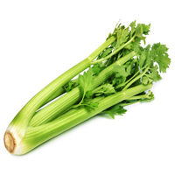
½ potato, diced
125 mL diced canned tomatoes
375 mL hot water
10 mL beef bouillon powder
1 mL dried basil
1 mL dried oregano
Pepper to taste

Directions:
- Prepare vegetables: wash, peel, and cut according to directions above; peel and mince the garlic.
- Meanwhile, in a large saucepan, over medium heat, lightly brown ground beef. Add onions, celery, carrots, potatoes and garlic. Continue to cook, stirring often with a wooden spoon for about 3-5 minutes.
- Add beef bouillon to hot water and stir to dissolve.
- Add prepared beef stock, diced canned tomatoes and seasoning to vegetable-beef mixture and bring to a boil.
- Reduce heat to medium-low and simmer for about 15 minutes or until vegetables are tender when tested.
- Serve in a soup bowl and enjoy.

