Foods 9-10(A) 2017 Vint
SPECULAAS
(Dutch Spice Cookies – Cake Method)
One recipe per unit of 4-5 students

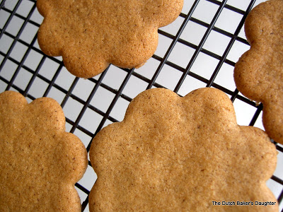
250 mL all-purpose flour
4 mL baking powder
5 mL cinnamon
1 mL ground allspice
65 mL margarine, at room temperature
185 mL dark brown sugar
1 egg, well beaten
2½ mL vanilla

- In a small mixing bowl, combine flour, baking powder, cinnamon and allspice.

- In a large mixing bowl, beat margarine with brown sugar until light and fluffy. Add egg and vanilla. Mix well.

- Stirring constantly, add flour mixture a little at a time.

- Form dough into a ball, cover and refrigerate for 20 minutes, or as long as possible. (If making this at home and you have more time, refrigerate for at least one hour.)

- Preheat oven to 350ºF (175C). Lightly grease a baking pan.

- On a lightly floured surface, roll out dough ⅛” (3 mm) thick. Using a cookie cutter or knife, cut out dough into desired shapes.

- Place cookies on prepared pan about 1” (2½ cm) apart and bake for about 12-15 minutes until lightly browned.

- Remove from oven and cool for about 2 minutes on the pan before removing to a wire rack with a thin metal spatula or flipper.

- Store cookies in an airtight container. They may also be frozen for up to 2 months.

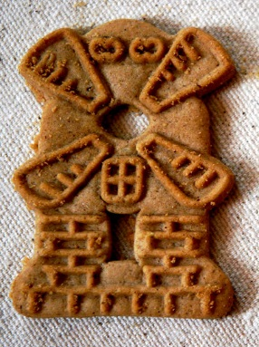
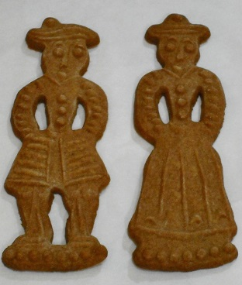

Name: _________________________

Block: __________ Unit: __________

Questions for Speculaas Lab

- The THICKER you roll and cut out the cookie dough, the _______________ the cookies will be.

The THINNER you roll and cut out the cookie dough, the _______________ the cookies will be.

- List/name the spices/flavourings used in this recipe:

- Why is it best to refrigerate the dough until it is firm before rolling it out?

- To help these cookies keep their shape better during baking, what can we do with them after they have been cut out?

- What is the difference between dark brown sugar and light/golden brown sugar (other than the colour difference)?

- Why is it best to keep the cookies on the baking sheet/pan for 2 minutes before we remove them and place them on a wire cooling rack?

- Why should margarine be at room temperature when making cookies?

