UPSIDE-DOWN APPLE PANCAKES (Dutch)
One recipe per unit of 4-5 people
15 mL margarine
25 mL sugar
15 mL brown sugar
5 mL cinnamon
1 apple, peeled, cored and thinly sliced (evenly and neatly)
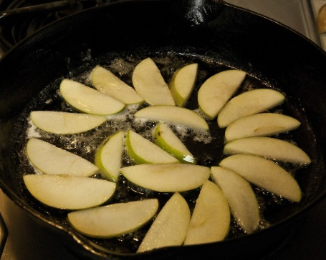
BATTER:
40 mL all-purpose flour
1 mL baking powder
1 egg yolk *
40 mL milk
2 egg whites *
40 mL sugar

* Note:
To avoid wasting or storing extra egg yolk(s), use one egg (separated) and 25 mL liquid egg white.

- Preheat oven to 400ºF. Grease sides only of a full-size pie plate or oven-safe frying pan. Greasing is not necessary in a non-stick pan. Prepare apple as above.
- Place margarine in the pie plate or frying pan and heat/melt in oven for about 2 minutes.
- Combine sugar (25 mL), brown sugar and cinnamon. Sprinkle over butter and bake for 2 minutes.
- Arrange thinly sliced apples over the sugar-cinnamon mixture and bake for 10 minutes.

BATTER:
- After the apples go in the oven, prepare the batter. In a medium mixing bowl, combine flour and baking powder. Combine egg YOLK with milk. Blend in to flour mixture and set aside.
- In a separate small mixing bowl, beat egg whites (2) until soft peaks form. Gradually add sugar and continue beating until stiff peaks form.
- Fold beaten egg whites carefully in to milk mixture until well blended. Spread batter evenly and smoothly over apples.
- Bake for about 15 minutes or until lightly browned
- Remove from oven and loosen edges.
- Place a plate over the pancake. Invert so pancake falls on to serving plate.
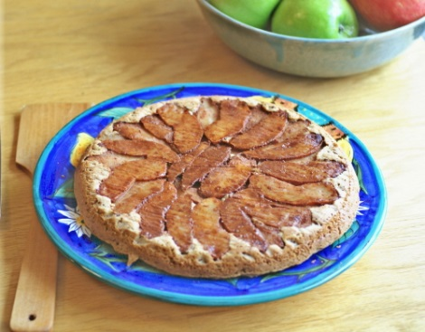
- Cut into wedges and enjoy warm.
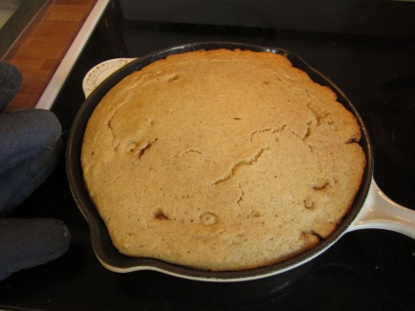

2015 Foods 9-10 A
Questions for Upside-Down Apple Pancake Lab

- Briefly describe two ways to separate eggs.

- Why is it important that you do not get any yolk into the separated egg white?

- Briefly describe what soft peaks look like.

- How can you tell if you have stiff peaks?

- Briefly describe the method of “folding in.”

What piece of kitchen equipment will you need to use for this task?

- Briefly describe how you should invert the pancake on to the serving plate.

- How should/could the apples be arranged?

- Draw a diagram of how you would arrange the apples.

