NAME: ___________________________
BLOCK: __________
WHAT DO YOU KNOW/REMEMBER?
Answer as many questions as you can from memory before consulting with your group members.

- SAFETY
  - Explain the route you would take from this room to the outside assembly area in case of a fire or fire drill. ________________________________________________________________________
____________________________________________________________________
  - A pot on the stove contains oil and catches on fire. Which of the following items could you use to put the fire out? (Circle all that apply)

    - Baking powder b) Water c) Baking soda d) The pot’s lid
  - There is a hot frying pan on the stove. The handle is also hot. With what should you cover your hand to lift the pan off the stove? (Circle all that apply)

    - A wet dish cloth b) An oven mitt c) Your apron

  - You have shaped hamburger meat patties on a cutting board and then placed them on a plate while the barbecue is heating up.
    - Where should you keep the meat patties while the barbecue is heating up?
____________________________________________________________________________
    - What should be done with the cutting board, and why?
____________________________________________________________________________
    - Is it safe to put the cooked hamburger patties back on the same plate that held them when they were raw? Explain.
____________________________________________________________________________
  - There is a broken glass measuring cup on the floor. Explain how to pick up the larger pieces and the tiny pieces.
_______________________________________________________________________________

_______________________________________________________________________________

_______________________________________________________________________________

- EQUIPMENT

  - Draw the following knives and state their common use(s):
Drawing Use(s)

    - _____________________________________
_____________________________________
    - _____________________________________
_____________________________________
    - _____________________________________
_____________________________________

  - Which utensil(s) would you use for the following?
    - Cutting in (as in making pastry) _____________________________________
    - Creaming _____________________________________
    - Folding in _____________________________________
    - Melting 15 mL margarine (2 ways) _____________________________________
_____________________________________
    - Chopping walnuts (2) _____________________________________
    - Kneading _____________________________________

- WASHING DISHES
  - Wash your hands. Find the following pieces of equipment and place them on your table:
Custard cup Cutting board Whisk Utility tray Bench Scraper
Pastry blender Mixing bowl Fork Paring Knife Cereal bowl

  - Set up the sink area as you would for washing dishes, placing the items from the table on the utility tray beside the sink. Number the following clean-up tasks in the correct order.
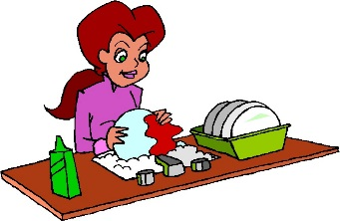
_______ Rinse _______ Wash _______ Dry _______ Rinse

_______ Stack _______ Drain _______ Scrape/Wipe

  - Refer to the items on the utility tray.
Which item would you wash first? ___________________________________________________

Which item would you wash last? ___________________________________________________

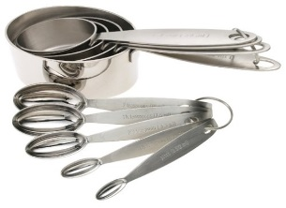
- MEASUREMENT

  - Write the abbreviations for the following:
_______ Degrees Fahrenheit _______ millilitre _______ hour
_______ minute _______ few grains _______ gram
_______ pound _______ ounce _______ kilogram
_______ milligram _______ litre _______ few drops
  - Answer the following:
    - Give two differences between a liquid measuring cup and a dry measure (not the material from which they are made).

      - _________________________________________________________________________
      - _________________________________________________________________________
    - What are the five sizes of our measuring spoons?
____________________________________________________________________________
    - What are the four sizes of our dry measures (metric & Imperial)?
____________________________________________________________________________
    - Explain two different methods to measure solid fat. Be specific.
      - _________________________________ ii) __________________________________
    - Give two reasons for sifting flour before measuring it.
      - _________________________________ ii) __________________________________
  - What utensils would you used to measure the following?
** Note the name/type AND size of ALL tools needed **
20 mL sugar ___________________________________________________________________
3 mL nutmeg ___________________________________________________________________
175 mL flour ___________________________________________________________________
45 mL brown sugar _______________________________________________________________
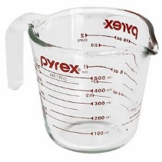
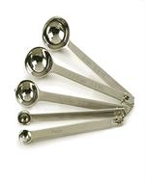
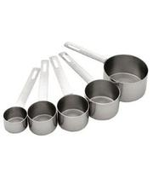
75 mL milk ___________________________________________________________________

- STOVE SAFETY

  - A recipe says to SIMMER a sauce for 15 minutes.
    - At what heat setting would you start the sauce? ____________________________________
    - How long would you leave it on this heat? _________________________________________
    - At what heat level would you continue cooking the sauce? ____________________________

  - You are going to sauté some onions in butter in a cast iron frying pan.
    - At what heat setting would you preheat the pan? ___________________________________
    - Would you add the onions to the cold pan? ________________________________________
    - At what heat would you sauté? __________________________________________________

  - When baking, does it matter if you preheat the oven? Yes or No (circle one) Why?
_______________________________________________________________________________
  - Where in the oven (bottom, middle, top) should products be placed to bake? Why?
_______________________________________________________________________________
  - Explain the safe way to place something in a HOT oven.
    - Door _______________________________ b) Rack ________________________________
  - Explain how to preheat the broiler.
Set dial at: ____________ Door position: ____________ How long? __________
  - Do you broil with the oven door open or closed? Why?
_______________________________________________________________________________
  - How do you adjust the intensity of heat when broiling?
_______________________________________________________________________________
