Foods 9-10 (B)

Whole Wheat Pumpkin Pecan Pancakes
Adapted from: Skinnytaste.com
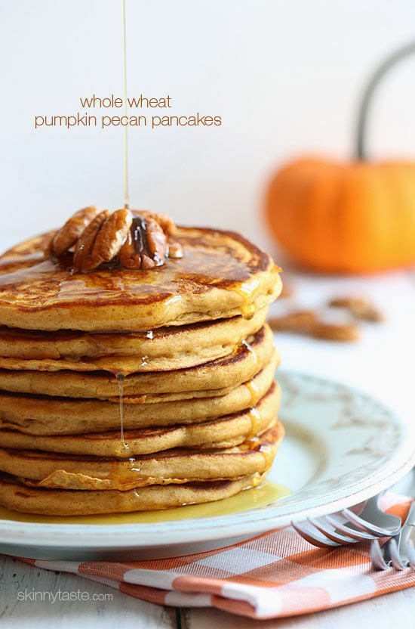
Whole wheat buttermilk pancakes made with whole wheat flour, pumpkin puree, pure maple syrup, pumpkin spice and pecans – a perfect lazy Sunday morning breakfast.
Servings: 2 Size: 2 pancakes
Calories: 234 Fat: 8 g
Carbohydrates: 31 g Fiber: 4 g
Protein: 10 g Sugar: 11 g
Sodium: 497 mg Cholesterol: 3 g
Ingredients:
- 125 mL whole wheat flour** ½ cup
- 5 mL baking powder 1 tsp
- ½ mL salt ⅛ tsp
- 1 mL cinnamon ¼ tsp
- 2 mL pumpkin pie spice ½ tsp
- 125 mL buttermilk ½ cup
- 2 med egg whites (about 50 mL) 2 med
- 30 mL canned pumpkin 2 Tbsp
- 15 mL pure maple syrup 1 Tbsp
- 2 mL vanilla ½ tsp
- 5 mL oil 1 tsp
- 15 mL chopped pecans 1 Tbsp

- cooking spray OR 5-10 mL vegetable oil
- warmed maple syrup, for topping (extra)

* *You may use half whole wheat and half all-purpose flour if you prefer.

Method:
- Mix all dry ingredients (first 5) together in a medium bowl.
- Combine buttermilk, egg whites, canned pumpkin, maple syrup, oil and vanilla in a small bowl and mix until smooth.
- Combine wet ingredients with the dry and mix well with a spoon until there are no more dry spots. Fold in pecans. Don't over-mix. (Sound familiar? It’s the “muffin method!”☺)
- Heat a large skillet (frying pan) on medium-low heat. Spray or brush with oil to lightly coat the pan.
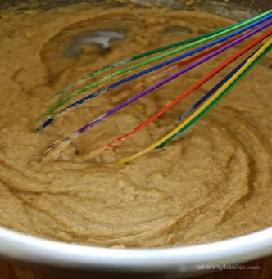
- Pour in 60 mL (¼ cup) of pancake batter. When the pancake starts to bubble and the edges begin to set (about 2 minutes) then flip the pancakes and cook an additional 1 1/2 to 2 minutes. Repeat with the remainder of the batter.
- Serve warm topped with warmed maple syrup.

*Note:
If you don’t have buttermilk on hand, put 15 mL (1 Tbsp) of vinegar or lemon juice
In a measuring cup, then add your milk (whole, 1%, 2% or skim works fine) to the
250 mL (1 cup) line and let stand for 5 minutes.
This is a good substitute for using regular buttermilk.

November 2013

