**APPLE SQUARES**

One recipe per 2-3 people (max 2 recipes per unit)

C:\Users\Vint\AppData\Local\Microsoft\Windows\Temporary Internet Files\Content.IE5\G1WE6DWB\MC900432485[1].wmf

Metric Imperial

50 mL margarine 3 Tbsp

125 mL sugar ½ cup

1 egg 1

2½ mL vanilla ½ tsp

125 mL flour (sifted or lifted) ½ cup

 2½ mL baking soda ½ tsp

½ mL cinnamon 1/8 tsp

250 mL apple, chopped **SMALL** 1 cup

(1 med apple, ~ ½-cm dice)

15 mL lemon juice 1 Tbsp

15 mL icing sugar (topping) 1 Tbsp

**METHOD:**



1. Preheat oven to 350°F (175C).
2. Grease sides of a large loaf pan with shortening or margarine.

Line bottom of pan with parchment paper and set aside.

1. Toss chopped apples with lemon juice to prevent browning.
2. In a medium-large mixing bowl, **thoroughly** cream together margarine and sugar.

Beat in egg and vanilla until thoroughly combined.

1. In a small-medium mixing bowl, combine flour, baking soda and cinnamon.
2. Using a wooden spoon, add the flour mixture to the creamed mixture.
3. C:\Users\Vint\AppData\Local\Microsoft\Windows\Temporary Internet Files\Content.IE5\Z0ECN4SP\MC900341012[1].wmf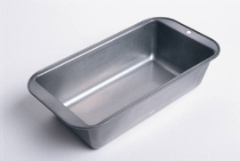Stir until well mixed.
4. Gently stir in finely-chopped apples.
5. With a rubber spatula, scrape batter into greased loaf pan.
6. 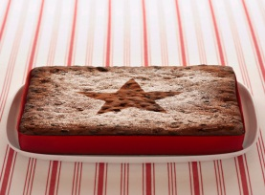Bake for 25-30 minutes, or until the loaf is golden brown, the top springs back when pressed, the edges shrink away from the sides of the pan and/or a toothpick inserted in the centre comes out clean.
7. Sprinkle with icing sugar (use a sieve).

Vint 2011