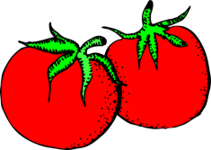
CANNED TOMATOES – HOT PACK
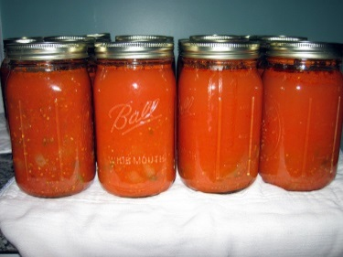
Yield: 500 mL (1 pint) per 2-3 people
Processing – Boiling Water Bath

3 med-large Roma or plum tomatoes.
2 mL kosher salt (no additives)
2 mL lemon juice

- Prepare jars - wash and sterilize. Prepare snap lids by softening sealing compound.
- Prepare tomatoes – blanch and peel.
- Cut tomatoes in quarters. Place in a medium-large pot and just BARELY COVER with water. BOIL for 2-3 minutes.
- Meanwhile, add salt and lemon juice to the empty jar.
- Pack hot tomatoes into the hot jar, leaving 1 cm (½“) head space after filling with cooking liquid.
- Remove air bubbles by running a sterile, narrow rubber spatula around the inside of the jar. Wipe off the rim of the jar with a slightly-damp, CLEAN cloth.
- Place softened snap lids on jars. Place screw band and tighten ONLY finger-tip tight.
- Immediately place filled jar(s), without tipping, in a boiling water bath canner. Cover pot and begin timing AFTER water returns to a full, rolling boil.
- Be certain that jars are fully immersed, with a minimum of 2-3 cm (1”+) of water (or more) above the tops of the jar(s). Also ensure that jars do not touch the bottom of the pot directly. Use a rack, or extra screw bands, tied together, as a base on which to place the jars.
- Process filled jar(s) for 15 minutes (for 500 mL/1 pint jars) or 35 minutes (for 1L/quart jars).
- After processing, remove jars (without tipping) and place on a clean, DRY towel.
- Do NOT tighten screw bands!! They may be removed when cool, if desired.
- Cool, upright, for at least 24 hours before storing.
- Test for seal when cooled:
- HEAR: “SNAP” sound when vacuum seal forms; hollow sound when lid is tapped
- SEE: lid curves downward
- FEEL: lid should not move up/down when pressed in the centre.

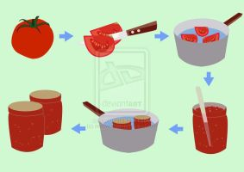

Vint 2016
TIPS FOR SUCCESSFUL CANNING:

- Use the best quality produce, free from blemishes, for the best result.
- Partially thawed, frozen, unsweetened fruits may be substituted for fresh. Thaw frozen fruit in refrigerator just until crushable; some ice crystals should still be present.
- Measure with precision. Accurate measuring helps ensure success and food safety.
- DO NOT alter ingredient measures, especially sugar!
- Use liquid measures to measure prepared fruits and liquids.
- Thoroughly wash and DRY all produce. Unclean fruit can cause spoilage growth in jams.
- Cook jam recipes in a large, DEEP stainless steel saucepan or Dutch oven to allow space for a full rolling boil without boiling over. When using added pectin, be sure to bring jam to a full rolling boil that cannot be stirred down BEFORE counting the one minute boiling time.

