**CHILI PEPPERS**

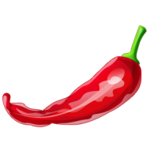

Chilies are member of the Capsicum family. There are more than 200 varieties of chilies, over 100 of which are indigenous to Mexico. They vary in length from a huge 30cm to 0.5cm. Some are long, narrow and no thicker than a pencil while others are plump and globular. Their heat quotient varies from mildly warm to mouth-blistering hot. A chili’s color can be anywhere from yellow to green to red to black. Dried chilies are available year-round. The availability of fresh chilies varies according to the variety and season. Choose those with deep, vivid colors; avoid chilies with any sign of shriveling or soft spots. Fresh chilies can be stored in the vegetable drawer of the refrigerator. As a general rule, the larger a chili, the milder it is. Small chilies are much hotter because proportionally, they contain more seeds and veins than larger specimens. Those seeds and membranes can contain up to 80 percent of a chili’s capsaicin, the potent compound that gives chilies their fiery nature. Since neither cooking nor freezing diminishes capsaicin’s intensity, removing a chili’s seeds and veins is the only way to reduce its heat. After working with chilies, it’s extremely important to wash your hands thoroughly; failure to do so can result in painful burning of the eyes or skin (wearing rubber gloves will remedy this problem). Chilies are used to make a plethora of by-products including chili paste. Tabasco sauce, cayenne and the dried red pepper flakes commonly found in pizzerias. Chilies are cholesterol free and low in calories and sodium. They’re a rich source of vitamins A and C, and a good source of folic acid, potassium and vitamin E.

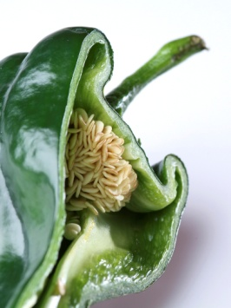

Capsaicinoids, are not soluble in water, but very soluble in fats, oils, and alcohol. This is why drinking water after accepting a dare to eat an extremely hot chili such as a Habanero, it won’t stop the burning. Downing a cold beer is the traditional remedy, but the small percentage of alcohol will not wash away much capsaicin. To get some relief from a chili burn, drink milk or eat ice-cream. Milk contains casein, fat-loving substance that surrounds and washes away the fatty capsaicin molecules in much the same way that soap washes away grease.

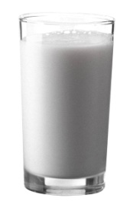

People that eat lots of spicy capsaicin-rich foods build up a tolerance to it. The incentive: Once a person has become somewhat desensitized to the extreme heat of “hotter” chilies, he or she can start on a new culinary journey. Not being over powered by the heat factor, the palate now has the ability to explore the many diverse flavors offered by the myriad of different chilies that are currently available around the world. Also for some Chili-Heads a good jolt of capsaicin excites the nervous system into producing endorphins, which promote a pleasant sense of well-being that can last for several hours. The endorphin lift or “high”, makes spicy food mildly addictive and for some, an obsession.

**MEASURING THE HEAT**

In 1912 a chemists by the name of *Wilbur Scoville*, working for the Parke-Davis pharmaceutical company, developed a method to measure the heat level of chili peppers. The test is named after him, the Scoville Organoleptic Test”. It is a subjective dilution-taste procedure. In the original test, Wilbur blended pure ground chilies with sugar-water and a panel of “testers” then sipped the solution, in increasingly diluted concentrations, until they reached a point that the liquid no longer burned their mouths. A number was than assigned to each chili pepper based on how much it needed to be diluted before they could no longer taste (feel) the heat.

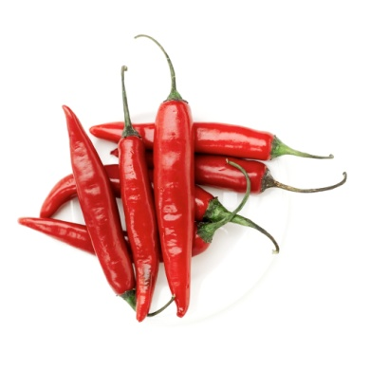

The pungency (or heat factor) of chili peppers is measured in multiples of 100 units. The sweet bell peppers at zero Scoville units to the mighty Habanero at 300 000 plus Scoville units Today a more scientific and accurate method called liquid chromatography is used to determine capsaicin levels. In honor of Dr. Wilbur the unit of measure is still named Scoville.

**THE WORLDS HOTTEST CHILI PEPPER**

The “Red Savina” Habanero has been tested at over 577 000 Scoville units! That is over 50 times hotter than the common Jalapeno. The Red Savina Habanero is listed in the “Guinness Book of World Records” as the world’s hottest chili pepper.

The Red Savina Habanero was developed from a mutant red pepper found in a field of orange Habaneros in 1989. It was found and developed by Frank Garcia, one of the 3 founders of GNS spices, which “owns” the Red Savina. The story goes that Frank was plowing under a large field of orange Habaneros rather than selling them at a much cheaper price than which was negotiated for before planting. In the process of destroying the crop he spotted a plant with red fruit growing in the field. One red fruited plant among all these orange ones was rather odd and got his attention. He stopped the tractor, plucked up the plant and tossed it on the tractor and forgot about it for a while. The seeds from that single plant were grown, and through selective breeding, the Red Savina strain was developed. In 1994, the Red Savina set a record for heat at 577 000 Scoville units. There have been a few contenders and some who have tried to cheat by adding capsaicin extract, but to date the Red Savina Habanero is without a doubt the world’s hottest chili pepper grown on the planet earth.



**Name:** _______________________



**Block:­­­**________ **Unit:­­**_______

**EAT THE HEAT: CHILIES**

1. What is a “chili-head? _______________________________________________________________.

2. How many types of chilies are indigenous to Mexico? __________________________________.

3. When buying fresh chilies, you should avoid chilies that are ______________________ and have

___________________.

4. How can you reduce the amount of heat when using chilies? ________________________________

___________________________________________________________________________________.

5. Why are smaller chilies much hotter than larger chilies? ____________________________________

___________________________________________________________________________________.

6. What is the potent compound found in chili’s that gives its fiery nature? ______________________.

7. What vitamins are chilies consider being a rich source of? _______________and ______________.

8. What units are used to measure the heat in chilies? _______________________________________.

9. Habanero chili peppers are how many times hotter than jalapenos? __________________________.

10. What is the name of the original method used to measure the heat level of a chili pepper?

____________________________.

11. What is the name of the more scientific and accurate method used today to measure the heat level of a chili pepper?

___________________________________________________________________________________.

12. How many units of Scoville is the habanero pepper measured at? ___________________________.

12. What is the hottest pepper in the world? ____________________ Heat level? _________________.

14. Who is the founder/developer of the hottest pepper? ­­­­_________________________________.