Foods 9-10 (A)

**Chocolate Dipped Orange Biscotti**

Makes 10 – 12 small cookies.

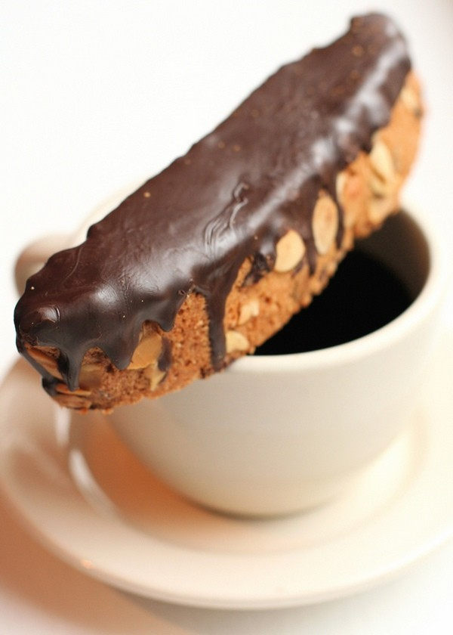

**Day 1 of lab:**

250 mL all-purpose flour 1 cup

125 mL granulated sugar ½ cup

1 mL baking powder ¼ tsp

1 mL baking soda ¼ tsp

1 mL salt ¼ tsp

1 egg (whole) 1

1 egg white 1

125 mL chopped almonds ½ cup

30 mL orange zest 2 Tbsp

**\*\* Note:** you may use 30 mL pasteurized egg white instead of the 1 egg white.

1. Preheat oven to 375F (190C).
2. Lightly grease a baking sheet/pan with ***shortening*** or line with parchment paper.
3. In a medium bowl, stir together flour, sugar, baking powder, baking soda and salt. Separate 1 egg and reserve the yolk for another use (or use 30 mL liquid egg white). Beat in the whole egg and egg white, then stir in almonds and orange zest.
4. Knead dough by hand until mixture forms a smooth ball.
5. Shape dough into a 23cm-long, by 5cm-wide, by 2½-cm high (9x2x1-inch) log.
6. Bake for 20 to 25 minutes or until firm. Cool 10 minutes on baking sheet then transfer to wire rack to cool completely. Wrap air-tight, label and freeze for next class.

**Day 2 of lab:**

1. Preheat oven to 325F (165C). Using a serrated knife and avoiding pressing down, gently slice the loaf diagonally into 2.5-cm (1-inch) thick slices.
2. Place the slices on the baking sheet, laying them on their sides (cut-side-down or lying flat). Bake for 10 to 15 minutes on each side, or until dry. Cool completely.

**Meanwhile, prepare chocolate for dipping:**

110 g semi-sweet chocolate (4 x 1-oz squares or 150 mL chocolate chips)

1. Melt chocolate slowly in a double boiler over very hot (not boiling) water. Make sure that no water gets in the bowl of chocolate or it will “seize.”
2. Allow chocolate to cool slightly but not harden before dipping one side of the biscotti (or one end) into it. Place cookies, chocolate side up, on waxed paper until cool and dry.

* Dry biscotti will keep for months if stored properly in an airtight container. Never store dry biscotti with moist cookies - the biscotti will absorb their moisture and become soggy.

Adapted from a recipe found at [www.allrecipes.com](http://www.allrecipes.com/)

