**CINNAMON BUNS**

(one recipe per unit)

**Ingredients:**

C:\Documents and Settings\mv12438\Local Settings\Temporary Internet Files\Content.IE5\IW0RLJQ0\MC900356969[1].wmf

One prepared recipe of Cinnamon Bun dough

25 mL margarine, melted

5 mL cinnamon

30 mL brown sugar

30 mL raisins (optional)

**Method:**

1. Bring refrigerated dough to room temperature and punch it down to remove large air bubbles.
2. Line a cake pan with foil and grease the foil lightly with shortening or cooking spray.
3. Roll the dough out into a rectangular shape about ¼” (8 mm) thick, or about the size of a sheet of photocopy paper.
4. Melt the margarine in the microwave (covered with a paper towel) for about 10-15 seconds or until liquid but not separated.
5. Using a pastry brush spread the margarine evenly over the dough. Leave a small strip along one LONG edge free of margarine so you can moisten it for sealing.
6. Combine the cinnamon, brown sugar and raisins (if using) and sprinkle over the margarine.
7. Dip your finger in water and moisten the inside of the margarine-free long edge slightly. Roll the dough sideways (so it ends up longer) like a jelly roll or a sushi roll. Pinch the seam shut and place seam-side down on a cutting board.
8. Using a sharp knife in a sawing motion, cut the roll into eight (8) **EQUAL**-width pieces (about 1” or 2-3 cm) and lay them cut-side-up so you can see the cinnamon swirl.
9. Arrange rolls evenly-spaced in the prepared pan. Cover loosely with a dry dish cloth.
10. Place oven racks in centre position and preheat oven to 375°F.
11. Place pan of rolls in a warm place on top of the oven while it preheats or in a proofing oven (about 150°F) and let rise for about 15-20 minutes or until doubled in bulk/size.
12. Bake rolls for 20-25 minutes or until they are golden brown.

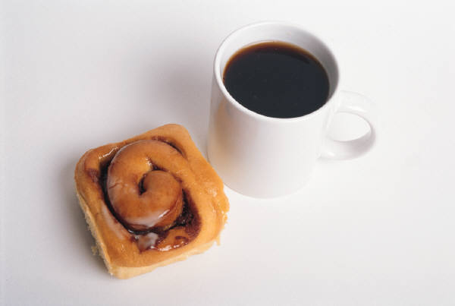

October 2013