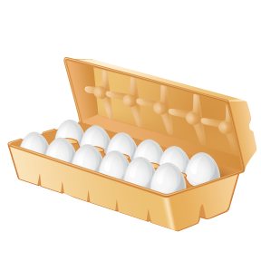
Name: ____________________

Blk: __________
EGGS
Food for Life (1st Ed.) p. 214-220:

- From p.215, draw a diagram of an egg and label the following:
  - shell b. air cell c. shell membrane d. chalazae (2 of them)
- albumen f. yolk g. germ spot

- The shell is made mainly of this mineral: ___________________________________
- Explain what the “bloom” is:
________________________________________________________________________________________________________________________________________________
- As the egg ages, what happens to the size of the air cell? ________________________________________________________________________
- As the egg ages, what happens to the consistency of the albumen? ________________________________________________________________________
- As the egg ages, what happens to the height of the yolk?
________________________________________________________________________
- Explain what happens at the spot called the germ:
________________________________________________________________________
- What is the purpose of the chalazae:
________________________________________________________________________
- Describe the criteria by which EGGS are GRADED:
Criteria | Description
Shell
Yolk
Abnormalities

- Provide the definition of the following GRADES of EGGS:
Grade | Description
Grade A
Grade B
Grade C
Canada
Nest Run

- Explain how eggs are priced:
________________________________________________________________________
- Which size do most recipes call for: ___________________________________________
- How should eggs be stored to maintain their freshness: ________________________________________________________________________
- How many eggs equals ONE serving of a Meat & Alternative: ______________________
- Read the chart carefully:
  - How many calories are in ONE large egg: ________________________________
  - How much protein is in ONE large egg: __________________________________
  - How much fat is in ONE large egg: ______________________________________
  - Which vitamin is in the greatest amount: ________________________________
  - About __________% of the RDI (recommended daily intake) of IRON is provided by 2 large eggs.
  - About __________% of the RDI (recommended daily intake) of IODINE is provided by 2 large eggs.
- Explain what COAGULATION means: ________________________________________________________________________________________________________________________________________________
- Describe the following ROLES (functions) of the EGG ( briefly define & give examples):
Thickener
Leavener
Binder
Clarifier
Coating Agent
Emulsifying Agent
Crystallization Preventative
