NAME: ___________________________
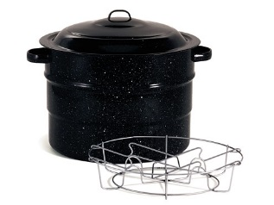
BLOCK: ________ UNIT: ________
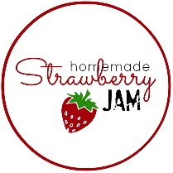

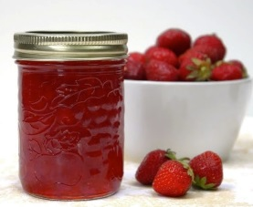

Food Preservation and Canning
Reference: Management & Foods: pages 379 – 426

- What is “food preservation?” __________________________________________________
__________________________________________________________________________
__________________________________________________________________________
__________________________________________________________________________

- Why is food preserved? ______________________________________________________
__________________________________________________________________________
__________________________________________________________________________
__________________________________________________________________________

- What causes food to spoil? ___________________________________________________
__________________________________________________________________________
__________________________________________________________________________
__________________________________________________________________________

- What is an enzyme? What does it do in food? ____________________________________
__________________________________________________________________________
__________________________________________________________________________
__________________________________________________________________________

~ Page 2 ~
- Give 3 examples of micro-organisms and EXPLAIN what each one does in food.
a. ________________________________________________________________________
________________________________________________________________________
b. ________________________________________________________________________
________________________________________________________________________
c. ________________________________________________________________________
________________________________________________________________________

- List 5 methods of preserving food AND give one example of each.
a. ________________________________________________________________________
________________________________________________________________________
b. ________________________________________________________________________
________________________________________________________________________
c. ________________________________________________________________________
________________________________________________________________________
d. ________________________________________________________________________
________________________________________________________________________
e. ________________________________________________________________________
________________________________________________________________________

- What are food additives? ____________________________________________________
__________________________________________________________________________
__________________________________________________________________________
__________________________________________________________________________

~ Page 3 ~
- What criteria would justify the use of a food additive? ______________________________
__________________________________________________________________________
__________________________________________________________________________
__________________________________________________________________________
__________________________________________________________________________
- Give 5 reasons why food additives might be used:
a. ______________________________________________________________________
________________________________________________________________________
b. ________________________________________________________________________
________________________________________________________________________
c. ________________________________________________________________________
________________________________________________________________________
d. ________________________________________________________________________
________________________________________________________________________
e. ________________________________________________________________________
________________________________________________________________________
- What is “canning?” Describe/explain. __________________________________________
__________________________________________________________________________
__________________________________________________________________________
__________________________________________________________________________
- What factors determine the method of canning that should be used at home? ___________
__________________________________________________________________________
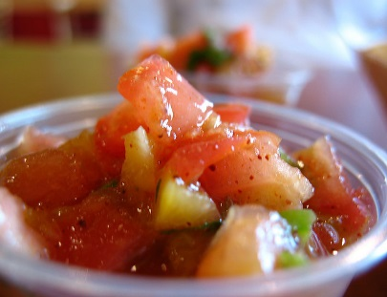
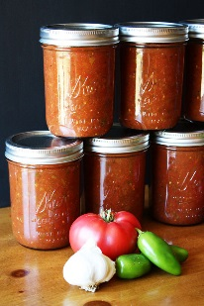

~ Page 4 ~
- Describe TWO common methods of home canning. _______________________________
__________________________________________________________________________
__________________________________________________________________________
- What method is NOT recommended for canning ANY food product? Why? ______________
__________________________________________________________________________
__________________________________________________________________________
- Describe how canned/jarred foods should be stored. _______________________________
__________________________________________________________________________
- When is it necessary to use a pressure canner? Why? _____________________________
__________________________________________________________________________
- Describe at least 3 typical signs of spoilage in canned food. _________________________
__________________________________________________________________________
__________________________________________________________________________
- What are “jellies?” (NOT candy) Describe the characteristics of a perfect jelly. ___________
__________________________________________________________________________
__________________________________________________________________________
- What is pectin? _____________________________________________________________
__________________________________________________________________________
- Describe how to sterilize canning jars. ___________________________________________
__________________________________________________________________________
__________________________________________________________________________
- What are:
a. Marmalades: _____________________________________________________________
b. Butters: _________________________________________________________________
c. Conserves: ______________________________________________________________
d. Preserves: _______________________________________________________________

