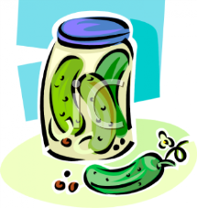
NAME: __________________________
Block: ______ Unit: ______
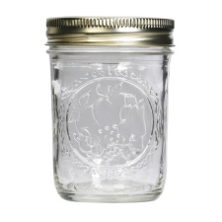
FOOD PRESERVATION and CANNING
Reference: Management & Foods, p. 379-426

- What is food preservation? __________________________________________
_______________________________________________________________
_______________________________________________________________
- Why is food preserved? ____________________________________________
_______________________________________________________________
_______________________________________________________________
- What CAUSES food to spoil? ________________________________________
_______________________________________________________________
_______________________________________________________________
- a) What is an enzyme? _____________________________________________
_______________________________________________________________
b) What does it do in food? __________________________________________
_______________________________________________________________
- Give 3 examples of micro-organisms and explain what each one does in foods.
  - ____________________________________________________________
____________________________________________________________
  - ____________________________________________________________
____________________________________________________________
  - ____________________________________________________________
____________________________________________________________

- Page 2 -
- List 5 methods of preserving food and give one example of each.
  - ____________________________________________________________
____________________________________________________________
  - ____________________________________________________________
____________________________________________________________
  - ____________________________________________________________
____________________________________________________________
  - ____________________________________________________________
____________________________________________________________
  - ____________________________________________________________
- What are food additives? ___________________________________________
_______________________________________________________________
_______________________________________________________________
- What criteria would justify the use of a food additive? _____________________
_______________________________________________________________
_______________________________________________________________
_______________________________________________________________
- List 5 reasons why food additives might be used.
  - ____________________________________________________________
  - ____________________________________________________________
  - ____________________________________________________________
  - ____________________________________________________________
  - ____________________________________________________________
- What is canning? __________________________________________________
_______________________________________________________________
_______________________________________________________________
_______________________________________________________________
- Page 3 -
- What factors should be considered to determine the method of home canning used?
_______________________________________________________________
_______________________________________________________________
- Describe TWO common methods of home canning. _________________________
_______________________________________________________________
_______________________________________________________________
- What method is NOT recommended today for canning any food product? Why?
_______________________________________________________________
_______________________________________________________________
- Describe how home-canned (-jarred) food should be stored? _________________
_______________________________________________________________
_______________________________________________________________
- When is it necessary to use a pressure canner? Why? ______________________
_______________________________________________________________
_______________________________________________________________
- Describe at least 3 typical signs of spoilage in canned food.
  - ____________________________________________________________
  - ____________________________________________________________
  - ____________________________________________________________
- What are jellies? Describe the characteristics of a perfect jelly.
_______________________________________________________________
_______________________________________________________________
_______________________________________________________________
- What is pectin? Why is commercial pectin added to fruit for making jam or jelly?
_______________________________________________________________
_______________________________________________________________
_______________________________________________________________
- Page 4 -
- How do you sterilize jars? ___________________________________________
_______________________________________________________________
_______________________________________________________________
_______________________________________________________________
_______________________________________________________________
_______________________________________________________________
_______________________________________________________________
- What are …
  - marmalades? __________________________________________________
____________________________________________________________
  - fruit butters? _________________________________________________
____________________________________________________________
  - conserves? ___________________________________________________
____________________________________________________________
  - preserves? ___________________________________________________
____________________________________________________________
