Foods 9-10(A)
Revised 2018
QUICHE
(2-day lab)
Makes 4 “Mini” Quiche
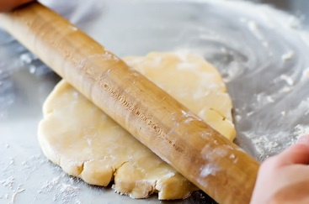

Day 1 – make pastry, wrap and store:

Pastry recipe for 4 small pastry shells (muffin tin size):

155 mL all-purpose flour
½ mL salt
40 mL shortening
30-40 mL ice-cold water (approximately!)

- In a large mixing bowl, combine flour and salt with a fork.

- Using a pastry blender, cut in shortening until it resembles green peas (coarse crumbs).

- Add water gradually and mix gently with a fork, JUST until mixture holds together. Gently gather the dough into a ball. Do not over-handle the dough or it will cause tough pastry.

- Divide pastry in four equal pieces. Roll each piece in a ball, then press into a disc shape. Wrap with layers of plastic wrap between each. Store in a labeled zippered freezer bag. Exclude as much air as possible.

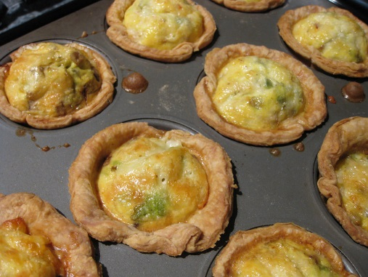

Day 2 – make filling, roll out and bake blind pastry shells

50 mL Cheddar cheese, finely grated
5 mL flour
⅛ med. onion, chopped finely
1 slice bacon (turkey or pork), diced
2 eggs
80 mL half-and-half, light cream, evaporated milk, or milk
f.g. salt, pepper and nutmeg

…/ over

- Pre-heat oven to 450ºF.

- Pastry should be at room temperature before proceeding. Roll out each piece of dough to fit the muffin tin cups. Trim dough if necessary to achieve a nice, round shape. Make sure the pastry comes ALL the way up the sides, ALL the way around the top edge of each cup. If the liquid filling escapes under the pastry, the quiche will become very stuck in the cups after baking. It’s best to use the four corner cups in a 6-cup pan.

- Line the unpricked pastry shells with a single thickness of foil. Fill each with rice, dried beans or peas. This is called “baking blind” and will prevent the bottom of the shell from puffing up and leaving no space for filling. Place on a lower rack in the oven and bake until edges are JUST BARELY beginning to brown, about 7-8 minutes. Too much browning now will result in a burnt crust after baking with filling. Remove from oven and reduce oven temperature to 400ºF. Remove foil and weights from pastry shells.

- Meanwhile, in a small pot/saucepan, cook diced bacon and onion until onion is tender and bacon is crisp. (*TIP: begin cooking diced bacon first. When partially cooked, add onion and continue to cook.) If using reduced-fat or turkey bacon, you may need to add a small amount (5-10 mL) of vegetable oil to the pot to prevent the bacon from sticking to the pot.

- In a large liquid measure, beat the 2 eggs with a fork until the white and yolk are well blended. Stir in the milk and seasonings. Mix thoroughly.

- Divide onion/bacon mixture evenly and sprinkle into the bottoms of the four empty hot, baked pastry shells.

- Mix grated cheese with flour and sprinkle evenly over the onion mixture in each pastry shell.

- Gently pour the egg mixture over the filling, being careful not to over-fill or let liquid egg come between the pastry and tin. Add a small amount of water to empty cups (about ¼ - full) to prevent the pan from warping. Be careful to not get water in or around pastry shells.

- Bake for 12-15 minutes, or until a knife inserted near the centre comes out clean (no raw egg, but there may be a bit of oil from the cheese or bacon). **Let stand for 5-10 minutes before serving to allow the quiche to set.

Here are some other options to try at home – be creative and have fun!

Substitute the cheese, onion, bacon and nutmeg in the recipe with one of these options:
- Quiche Lorraine: Swiss cheese, 10 mL bacon bits, f.g. nutmeg
- Champignon – Mozzarella cheese, 25 mL champignons (mushrooms), 1 mL oregano &/or basil, 10 mL finely chopped onion
- Carotte – Cheddar cheese, 30 mL finely shredded carottes (carrots), f.g. ground ginger

