Freeze-Ahead Apple Pie
Cookery Principle: Freezing; Starch thickeners
Yield: 2 small pies (one recipe per unit of 4-5 people)
*One group should focus on making the filling, while the other group makes the dough for the crust.*

Apple Filling:
3-5 mL salt ½ - 1 tsp
750 mL apples (2 medium) 3 cups
80 mL sugar ⅓ cup
15 mL cornstarch 1 Tbsp.
125 mL cold water ½ cup
5 mL lemon juice 1 tsp
15 mL margarine 1 Tbsp.
½ mL cinnamon ⅛ tsp

** Flavour of filling is often best when a tart type of apple (like Granny Smith) is combined with a sweeter variety, such as a Gala.

- Fill a medium mixing bowl half-full with cold water. Dissolve 3-5 mL salt in the water.
- Peel apples and cut in quarters. Remove cores. Keep in salt water until all are finished to prevent browning.
- In a medium-small saucepan (a pot), stir together sugar and cornstarch to separate the cornstarch granules and prevent lumpy thickening.
- Pour the lemon juice into the water, stir to combine, then stir the lemon-water in to the sugar-cornstarch mixture until thoroughly combined.
- Rinse the salt water from the apple quarters and slice each CROSSWISE into slices about 3 mm (⅛”) thick.
- Add apple slices to mixture in the saucepan and stir gently to coat apples.
- Bring this mixture JUST to a boil over high heat, then immediately reduce heat to medium-low (#2-3) and simmer GENTLY until liquid thickens and apple slices are just fork-tender.
**Do not stir too often or too fast or the apples may break up and you will make apple sauce. Some varieties of apples hold their shape better than others when cooked.**
- Place cooked apple mixture in foil-lined pans. Dot with margarine (drop 3-4 small clumps on top of each pie’s filling). Sprinkle with cinnamon, if desired.
- Wrap and seal carefully so the package is air-tight (no rips or tears) to avoid drying out (freezer burn).
Label with Block & Unit # and freeze. Once frozen, filling may be removed from the pan.

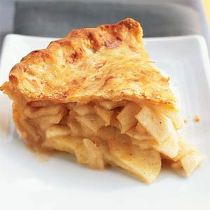
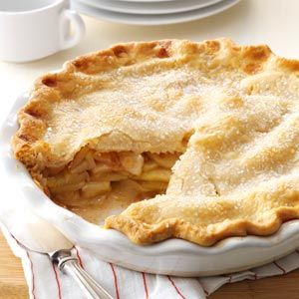

Foods 11-12(B) Vint 2016

Pastry for 2 Small Double-crust pies:
If you want to make a regular-sized pie, this recipe must be doubled.

250 mL all-purpose flour
2 mL salt
80 mL cold shortening or lard
cold water – enough to just hold together in a dough

- Sift together flour and salt.
- CUT IN the fat until it resembles coarse bread crumbs or green peas.
- Sprinkle cold water over flour, 15 mL at a time, lifting/tossing it in with a fork. Do not add more water under the previous addition has been incorporated.
- Continue to add water, just until a soft dough forms. You have enough water when you can take a small amount of the dough, squeeze it in your hand, and it holds together. DO NOT KNEAD DOUGH!
- Divide the dough into 4 equal pieces and flatten each into a disk.
- Wrap dough pieces, placing a layer of plastic wrap between each piece. Be sure the packaging is completely air tight! Label and place on tray for freezing.

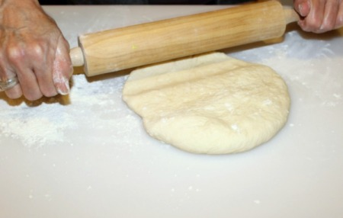

PIE TIME!

Preheat oven to 400ºF.

- Roll out each of the 4 pieces of defrosted dough so it is slightly larger in diameter than the pan.
- Lay one of the 4 circles of dough in the bottom of each of 2 small pie pans. Try not to stretch the dough.
- Unwrap the frozen pie filling packages and place one frozen filling on each bottom pastry crust.
- Moisten around the edges of the bottom crusts. Place the other pastry circles carefully over the filling, pressing down to seal all around the edges. Finish the edge of the crust as desired, either with “fluting” or by pressing with the tines of a fork, or the tip of a teaspoon turned upside-down. Top crust must be “vented” (holes cut or poked) to allow steam to escape, or the edges my come apart and the filling may leak out.
- Bake at 400ºF for about 40 minutes, or until crust is brown and filling is bubbling. Edges may be covered with foil partway through baking to prevent burning, if it looks like they are becoming too browned.

