French Toast Breakfast Muffins

These taste exactly like French toast! Made with skim milk and light butter, they are only about 120 calories a muffin if you make 6!
Muffin:
175 mL all-purpose flour
60 mL sugar
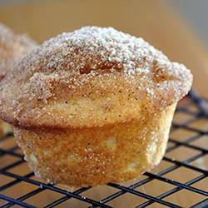
4 mL baking powder
1 mL salt
pinch nutmeg
60 mL milk
40 mL butter, melted
½ egg (~25 mL), lightly beaten &
preferably room temperature
Topping:
40 mL butter, melted
40 mL sugar
2 mL cinnamon
- Preheat oven to 350ºF.
- In a medium-large bowl, sift together all dry ingredients (NOT topping ingredients).
- Combine liquid/wet ingredients in a separate bowl or liquid measure.
- Add liquids to dry ingredients ALL AT ONCE and stir just until combined, but still a bit lumpy. Do NOT over mix! Over mixing will cause “tunnels” and spoil the texture of the finished muffins.
- Scoop batter into muffin tins that have been greased with shortening or sprayed with cooking spray.
- Scoop or spoon batter equally in to 6 muffin cups (⅔ full) to make 6 small-medium muffins. For larger muffins, fill 4-5 of the cups and fill any empty cups ½-full with water. Larger muffins will take longer to bake.
- Bake for 15-25 minutes (depending on muffin size) or until they just start to turn a bit golden at the edges and a toothpick inserted in the centre comes out clean.
- For the topping, mix sugar and cinnamon in a small bowl. Place melted butter in another small bowl.
- Dip the warm muffins in melted butter or brush on with a pastry brush (you can dip just the top, but it's even tastier to dip the whole muffin!), then dip/roll the muffin in cinnamon sugar. Enjoy while warm!

** To add maple flavour, try plating muffins then drizzle lightly with maple syrup.

