**C:\Documents and Settings\mv12438\Local Settings\Temporary Internet Files\Content.IE5\RE2O8P4B\MC900359571[1].wmfC:\Documents and Settings\mv12438\Local Settings\Temporary Internet Files\Content.IE5\RE2O8P4B\MC900233773[1].wmfFRESH APPLE COOKIES**

**(“Drop” cookie – 1 recipe per 2-3 people)**

**Ingredients:**

25 mL butter or margarine (softened) 125 mL flour

25 mL shortening (softened) 2½ mL baking powder

25 mL granulated (white) sugar ½ mL baking soda

25 mL brown sugar ½ mL salt

15 mL lightly beaten egg (about ¼ egg) 125 mL apple (about ½ medium apple)

2 mL vanilla extract 2 mL lemon juice

5 mL *cinnamon to sprinkle on tops (optional)*

**Method (creaming):**

1. Place oven racks in the centre and one just below the centre positions. Preheat oven to 350°F (press “Bake” then “^” buttons).
2. Grease a cookie sheet (baking pan) lightly with shortening (**NOT** the 25 mL above. That goes in your cookie dough) or line with parchment paper.
3. Wash, peel (optional – leaving the peel on gives some colour and texture), core and grate the apple (use larger size holes and press firmly). Sprinkle with lemon juice and toss to coat. The acid in the lemon juice deactivates the enzymes that cause the apple to turn brown. Set aside.
4. In a medium mixing bowl, **cream** butter/margarine and shortening together with a wooden spoon.
5. Add white and brown sugars and **beat** until light and fluffy. Stir in egg and vanilla until well combined.
6. In a small bowl, combine the dry ingredients (flour, baking powder, baking soda and salt).
7. Gradually add the dry ingredients into the creamed mixture and beat/stir until thoroughly combined.
8. Gently stir in grated apple until just combined.
9. Using two (small) teaspoons drop the dough onto the prepared pan. Leave enough space between cookies dough for cookies to spread during baking (3-5 cm). This amount of dough should make about 12 small cookies. If you make larger cookies, you may have to increase the baking time.
10. Sprinkle cookies with cinnamon if desired.
11. Bake for 10-15 minutes, depending on the size of cookies. You will know they are done when they just begin to turn a pale golden brown around the edges. These cookies are cake-like and are quite pale when baked. If you bake them until the tops are golden brown, they may be quite dry.
12. Once baked, remove the cookies from the oven and place the tray(s) on a wire rack or on the stove-top. **NEVER set a hot pan on the counter top.** Let the cookies cool slightly (or “set”) on the pan for 3-5 minutes then transfer carefully to a cooling rack using a metal spatula or a metal flipper.

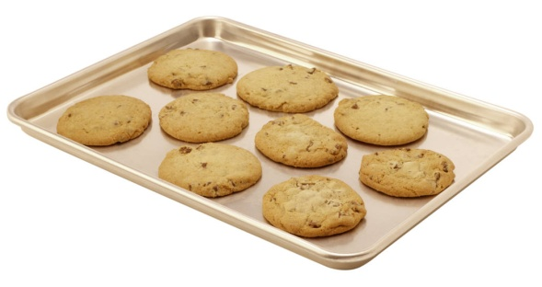

C:\Documents and Settings\mv12438\Local Settings\Temporary Internet Files\Content.IE5\NE7CDNTX\MC900412558[1].wmf

M. Vint – Sept 2012