Sauces for Gourmet Pizza Lab

TOMATO PIZZA SAUCE

250 mL plum or Roma tomatoes (about 2 small-med Roma tomatoes,
OR drained, canned whole tomatoes may be used)
10 mL olive oil
25 mL onion, minced (about 1 thin slice, or 1/8 of a small-med onion)
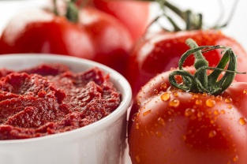
1 clove garlic, minced
Pinch dried oregano (or 3-5 leaves fresh, minced)
1 mL wine vinegar
Pinch each of salt, pepper and sugar

- Drain, seed and chop tomatoes, reserving juice if using canned tomatoes.
- In a small saucepan, heat oil briefly over medium heat. Add minced onion and dried oregano (if using dried) and sauté until onion begins to soften. Add minced garlic and (if using fresh) minced oregano. Continue to sauté until onion is translucent and garlic is softened (2-3 min).
- Add tomatoes, vinegar, salt, pepper and sugar. Simmer until thickened and flavours are blended, about 5-10 minutes. Remove from heat and allow sauce to cool for 5 minutes.
- Using an immersion/stick blender or a stand blender, blend until smooth, adding reserved juice, if desired, to reach a very thick, but spreadable consistency. If sauce is too thin for pizza, drain through a sieve if necessary.
- Spread sauce on prepared pizza dough crust and add toppings and cheese.

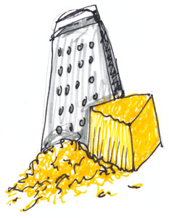

ALFREDO SAUCE

15 mL margarine 50 mL grated Parmesan cheese
15 mL flour ½ mL pepper
1-2 cloves garlic, minced 2 mL salt
125 mL light cream (10%)

- Melt margarine in a small pot over medium-low heat. Sauté minced garlic in melted margarine until just turning golden (1-2 minutes).
- Stir in flour until you have a smooth paste. GRADUALLY add cream, stirring constantly to prevent lumps from forming. Cook on medium-low heat until thickened and bubbly (it should bubble for at least 2 minutes to prevent a raw-starch taste.
- Add Parmesan cheese, pepper and salt (taste first before adding salt).
*Note – to make Pesto-Alfredo sauce, at this point, stir in 15-25 mL of prepared Pesto sauce.
- Spread sauce on prepared pizza dough crust and add toppings and cheese, or toss with the drained, cooked pasta of your choice.

Foods 11-12(A) 2017 Vint

