Foods 9/10
Butter Chicken
Serves 2-3
Ingredients:
1 – 1½ pieces chicken breast (½ piece per person)
2 mL garam masala
2 mL ground coriander
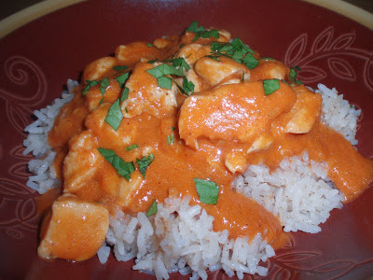
1 mL chilli powder
2 mL fresh ginger
1 clove garlic
5 mL white vinegar
15 mL tomato paste
30 mL yogurt
20 mL margarine or butter
¼ onion, finely chopped
f.g. cinnamon
1 mL ground cardamom
1 mL salt
3 mL paprika
100mL tomato puree
45 mL chicken stock
60 mL cream

Method:
- Combine garam masala, coriander, chilli powder, ginger, garlic, vinegar, tomato paste and yogurt in large bowl. Dice chicken and add to mixture. Stir to coat chicken. Set aside.
- Heat margarine/butter in frying pan. Add onion, cinnamon and cardamom. Cook, while stirring, until onion is browned lightly. Add chicken mixture and cook for 5 minutes, stirring frequently.
- Add salt, paprika, tomato puree and chicken stock. Simmer, uncovered for 10 min., stirring occasionally. Add cream and simmer (very gentle bubbling) for about 10 min. or until chicken is tender (no longer pink inside). Serve over rice. See other side!

Basmati Rice
(Per unit of 4-5 people)
- 250 mL basmati rice
- 500 mL cold water
- Pinch of salt
Method:
- In a medium pot, bring rice, water and salt to a boil. As soon as it is boiling, stir once or twice, turn heat to low-sim setting and cover with a tight-fitting lid.
- Don’t peek for 15 minutes! Set a timer.
- Taste to see if rice is done. It should be firm and fluffy, not crunchy nor soggy.
- Divide into bowls, cover with butter chicken and enjoy!

